Visoka škola strukovnih studija za

informacione i komunikacione tehnologije

Praktikum iz web programiranja PHP

Zlatanović Milan 158/16

Jun 2019, Beograd

Sadržaj

UVOD 3

TEMPLATE 4

index 4

logovanje i registracija 4

Proizvodi 6

Korpa 7

Profil 7

Korisnici 8

Organizacija foldera i fajlova 10

Dizajin baze 11

KODOVI 12

index.php 12

config/.env 13

config/config.php 13

config/connection.php 14

models/autor/autorIspis.php 14

models/autor/word.php 14

models/korisnici/dodajKorisnika.php 15

models/korisnici/excel.php 16

models/korisnici/izmeniKorisnika.php 17

models/korisnici/korisniciIspis.php 18

models/korisnici/obrisiKorisnika.php 19

models/korisnici/odjavaObrada.php 19

models/korisnici/prijavaObrada.php 19

models/korisnici/registracijaObrada.php 21

models/proizvodi/ispisKategorija.php 23

models/korisnici/ispisPorudzbina.php 23

models/proizvodi/ispisProizvoda.php 24

models/proizvodi/izbrišiProizvod.php 26

models/proizvodi/izmeniProizvod.php 27

models/proizvodi/izracunajCenu.php 27

models/proizvodi/korpa.php 28

models/proizvodi/obrisiKorpu.php 28

models/proizvodi/obrisiProizvodKorpa.php 28

models/proizvodi/poruci.php 29

pages/fixed/header.php 29

pages/fixed/footer.php 35

pages/404.php 46

pages/autor.php 46

pages/cart.php 47

pages/index.php 50

pages/korisnici.php 52

pages/pogresnaPrijava.php 56

pages/product.php 58

pages/profil.php 66

# UVOD

* Predstavljam vam sajt prodavnice zdrave hrane „Bio Like“ u Beogradu.
* Programski jezici korišćeni na sajtu:
  + HTML
  + CSS
  + JavaScript
  + Jquery
  + PHP
* Funkcionalnosti sajta:
  + Registracija
  + Logovanje
  + Dinamičko ispisivanje sadržaja iz baze
  + Dinamički meni
  + Filtriranje, sortiranje, search
  + Obrada slika
  + Popunjavanje korpe
  + Poručivanje proizvoda
  + log.txt fajl
  + Paginacija
  + Admin panel sa svim neophodnim funkcionalnostima
  + Export sadržaja iz baze u excel
  + Download word fajla popunjenog podacima iz baze
    - (Poslednje dve stavke su u kodu odrađene kao na lab vežbi, ali usled nemogućnosti učitavanja COM-a na localhostu, ovaj kod je zakomentarisan.)

# TEMPLATE

## index

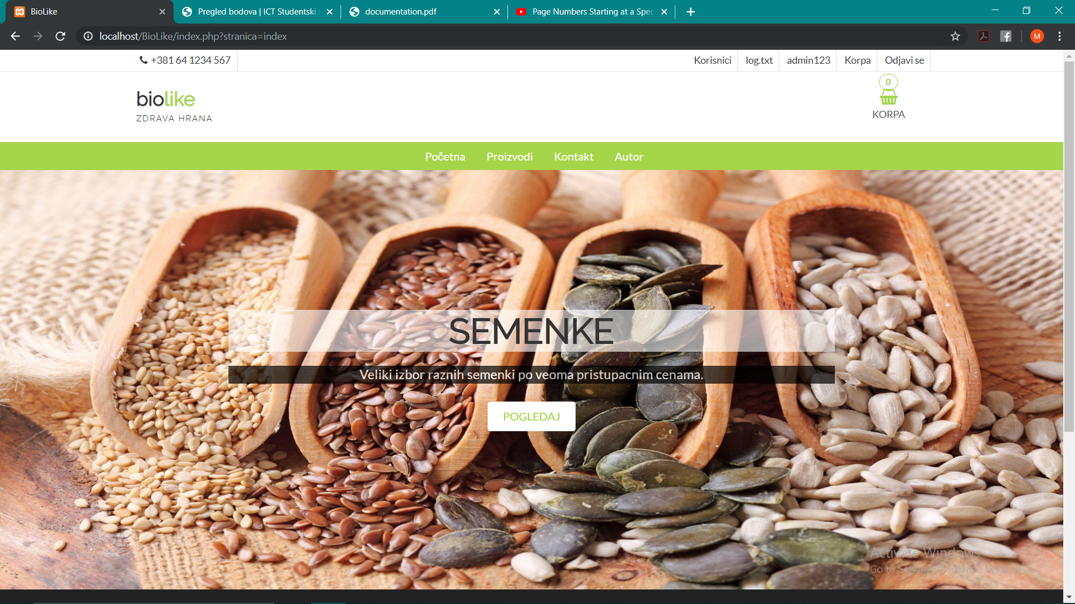

Dinamički učitani meni i slajder sa kategorijama proizvoda. Prilikom klika na taster POGLEDAJ na slajderu, otvara se stranica PROIZVODI sa kategorijom proizvoda prikazanoj na slajderu.

## logovanje i registracija

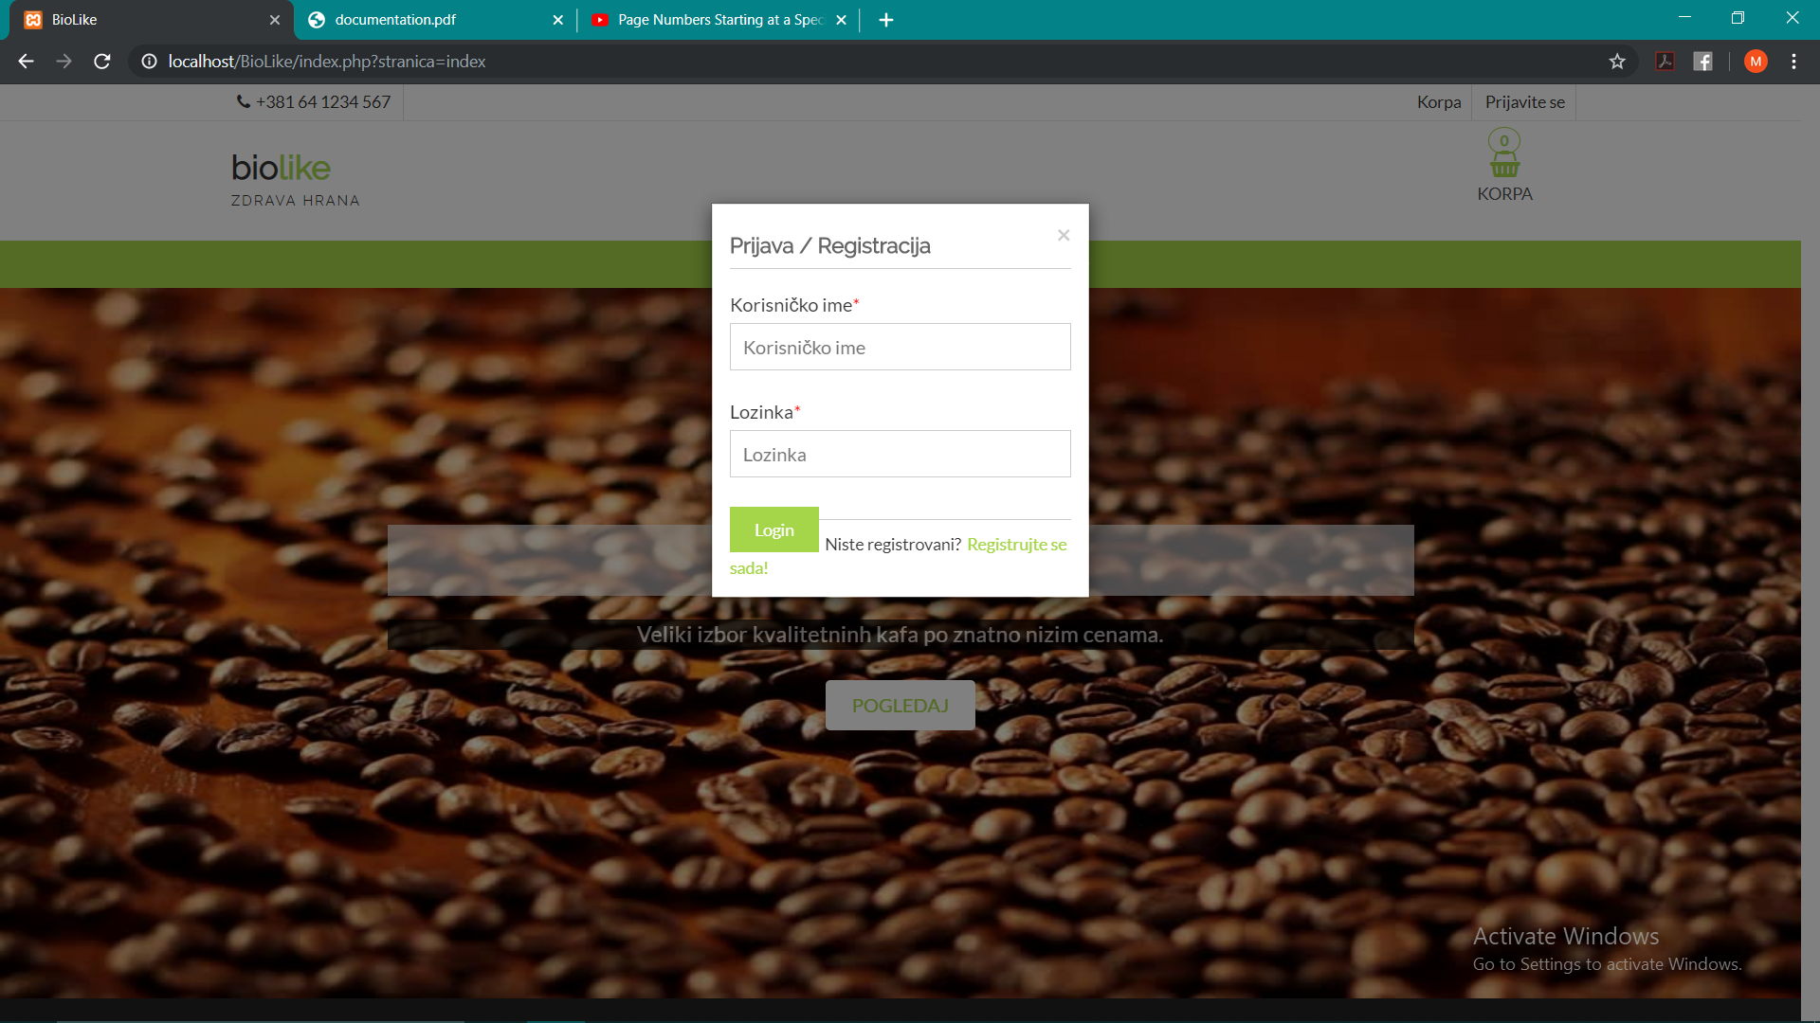

Odrađena je prijava korisnika. Prilikom uspešne prijave korisnik se upisuje u sesiju i omogućene su mu određene funckije koje neautorizovanim korisnicima nisu dozvoljene(pr. Poručivanje proizvoda).

Prilikom neuspešne prijave, prilikom koje je uneto odgovarajuće korisničko ime, korisnik se prosleđuje na stranicu na kojoj mu je naznačeno u čemu je greška, a na email mu se šalje poruka da je primećena neuspešna prijava sa njegovim korisničkim imenom.

Nakon uspešnog logovanja, na admin stranici u delu korisnici, prikazuje se da je korisnik ulogovan.

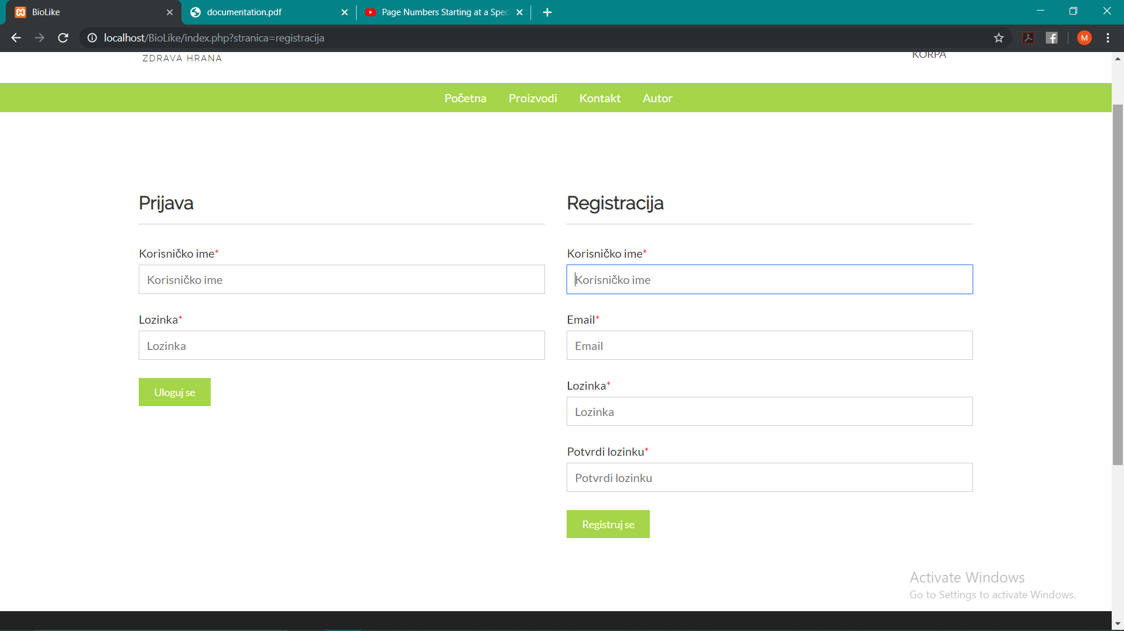

Registracija odrađena primenom serverskih i klijentskih regularnih izraza, nakon čega se korisnik upisuje u bazu u tabelu korisnici.

## Proizvodi

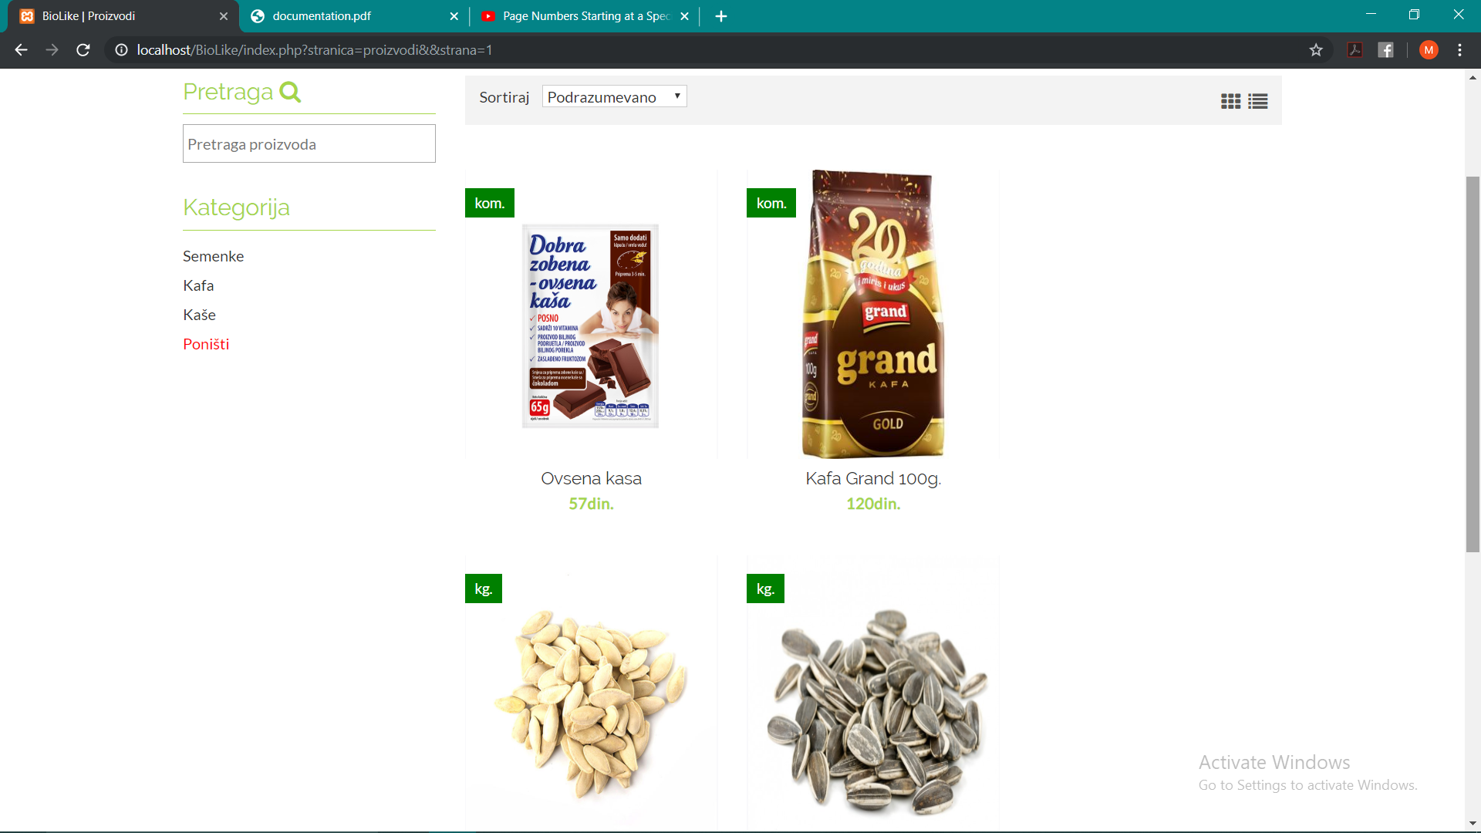

Dinamičko ispisivanje proizvoda iz baze, mogućnost filtriranja, sortiranja i search-a. Prelaskom mišem preko proizvoda, pojavljuje se mogućnost ubacivanja istog u korpu.

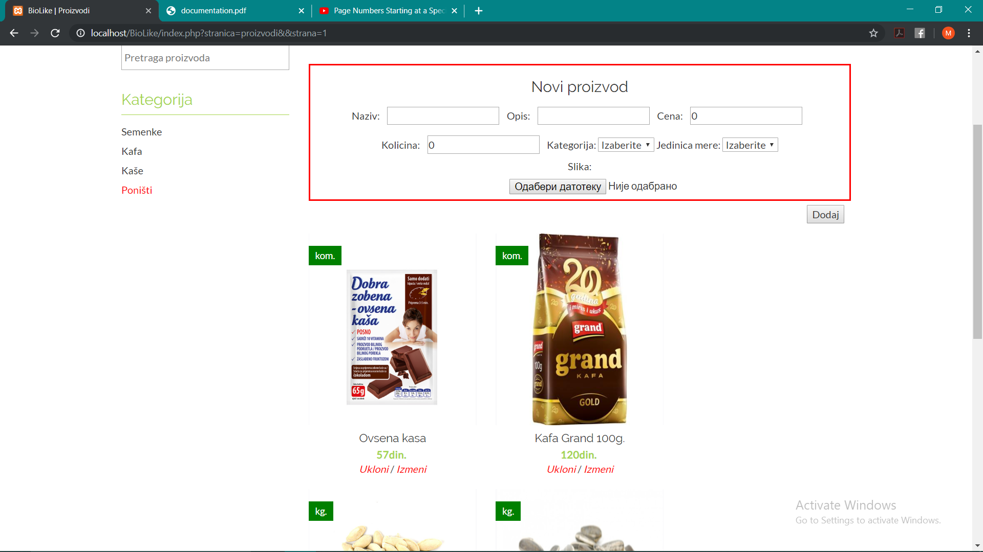

Stranica proizvodi iz ugla admina sajta. Mogućnost dodavanja, brisanja i izmene proizvoda.

## Korpa

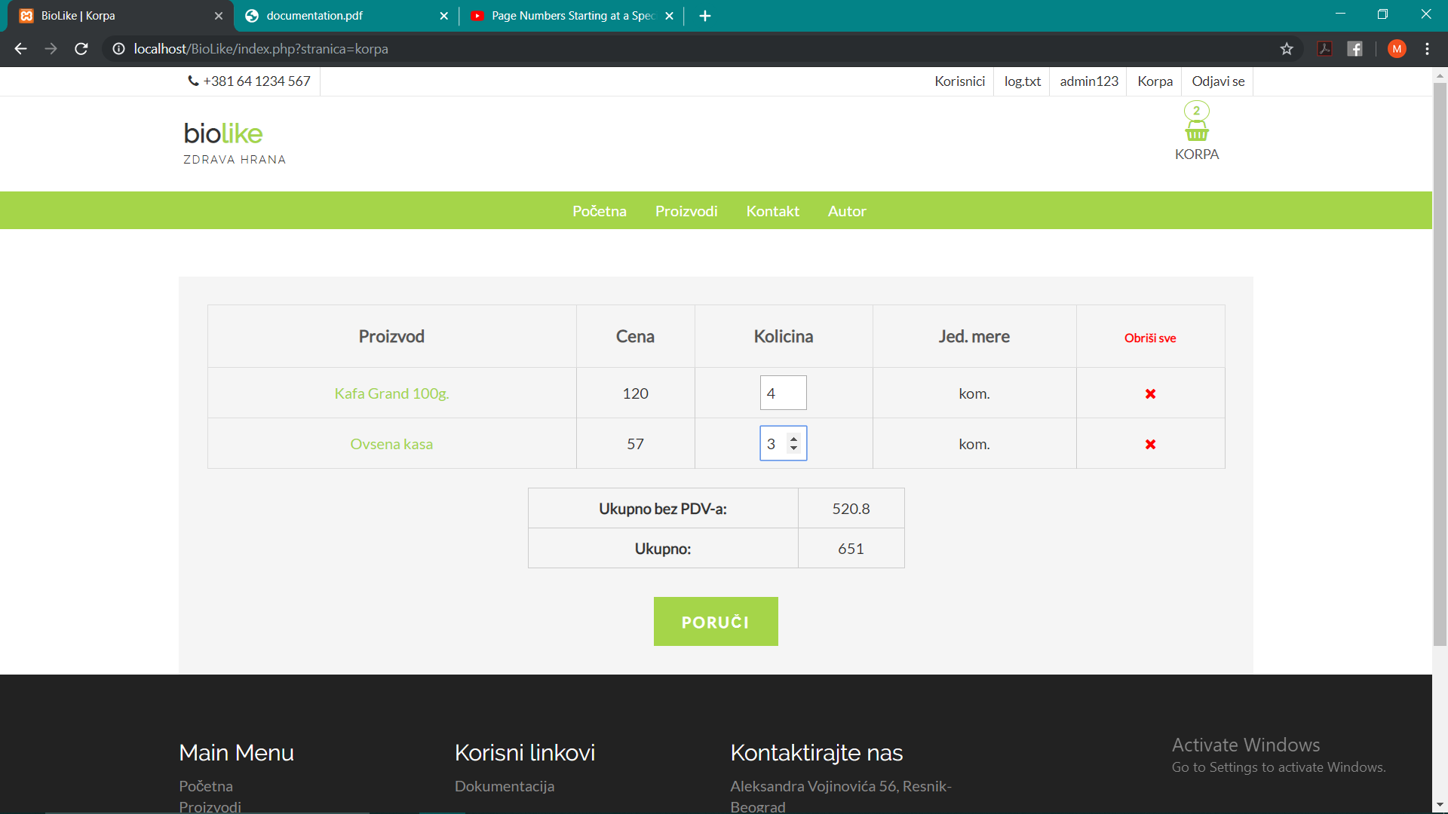

Kada se proizvodi dodaju u korpu, ovako će biti ispisani na stranici korpa. Prilikom promene količine proizvoda, automatski se izračunava ukupan iznos. Takođe je napravljena i mogućnost brisanja pojedinačnih ili svih stavki odjednom.

## Profil

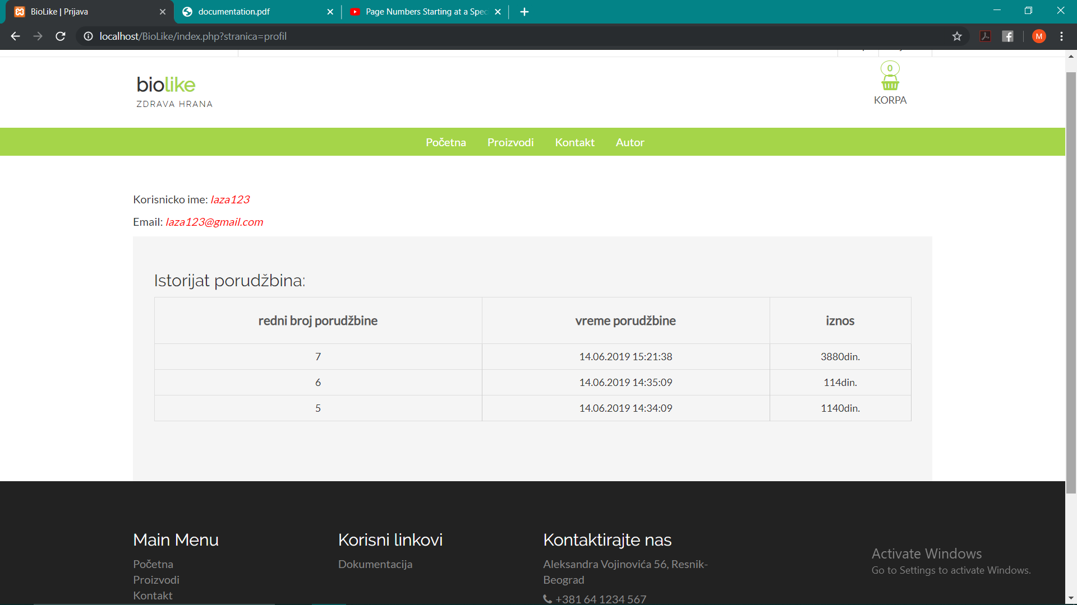

Kada na stranici korpa, kliknete na poruči, automatski ćete biti prebačeni na stranicu profil, gde će biti ispisani podaci o korisniku, kao i podaci o obavljenim porudžbinama. Admin će na ovoj stranici imati ispisane kompletne porudžbine sa korisničkim imenima korisnika koji su istu izvršili.

## Korisnici

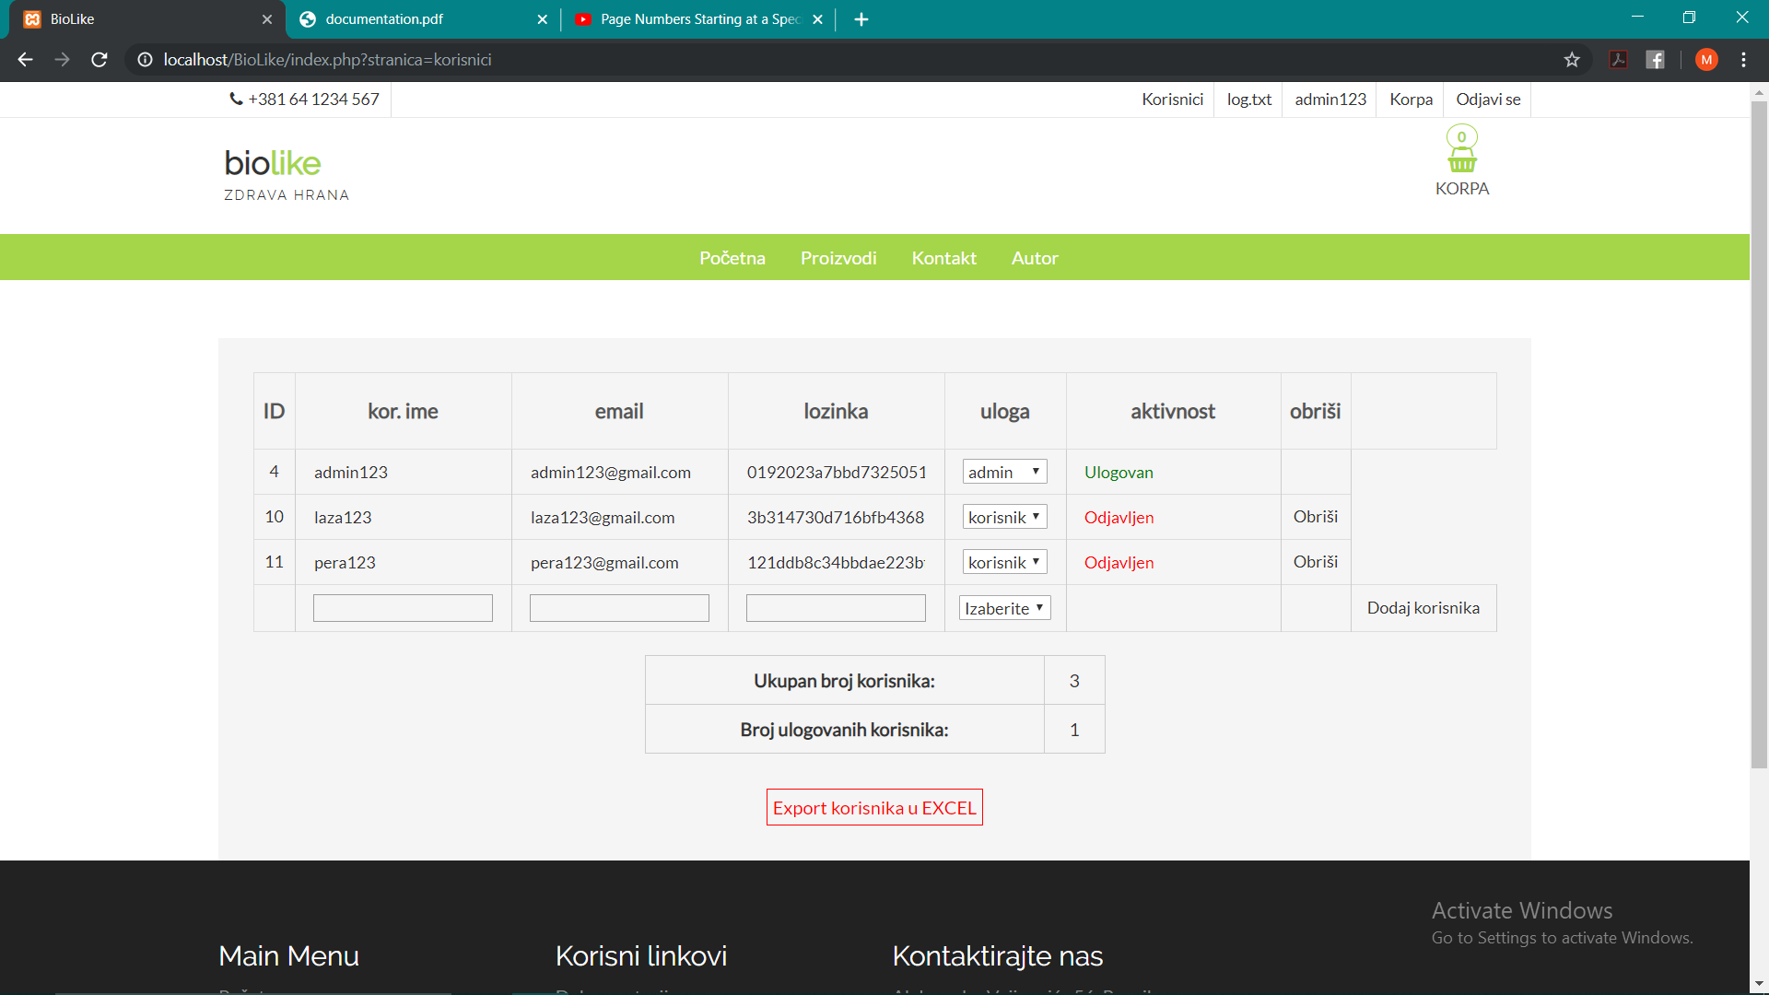

Stranici korisnik ima pristup samo korisnik sa ulogom admin. U ovom delu on će moći da upravlja korisnicima, biće mu ispisan njihov broj, kao i broj trenutno ulogovanih, a takođe može preuzeti spisak korisnika u excel-u.

## Organizacija foldera i fajlova

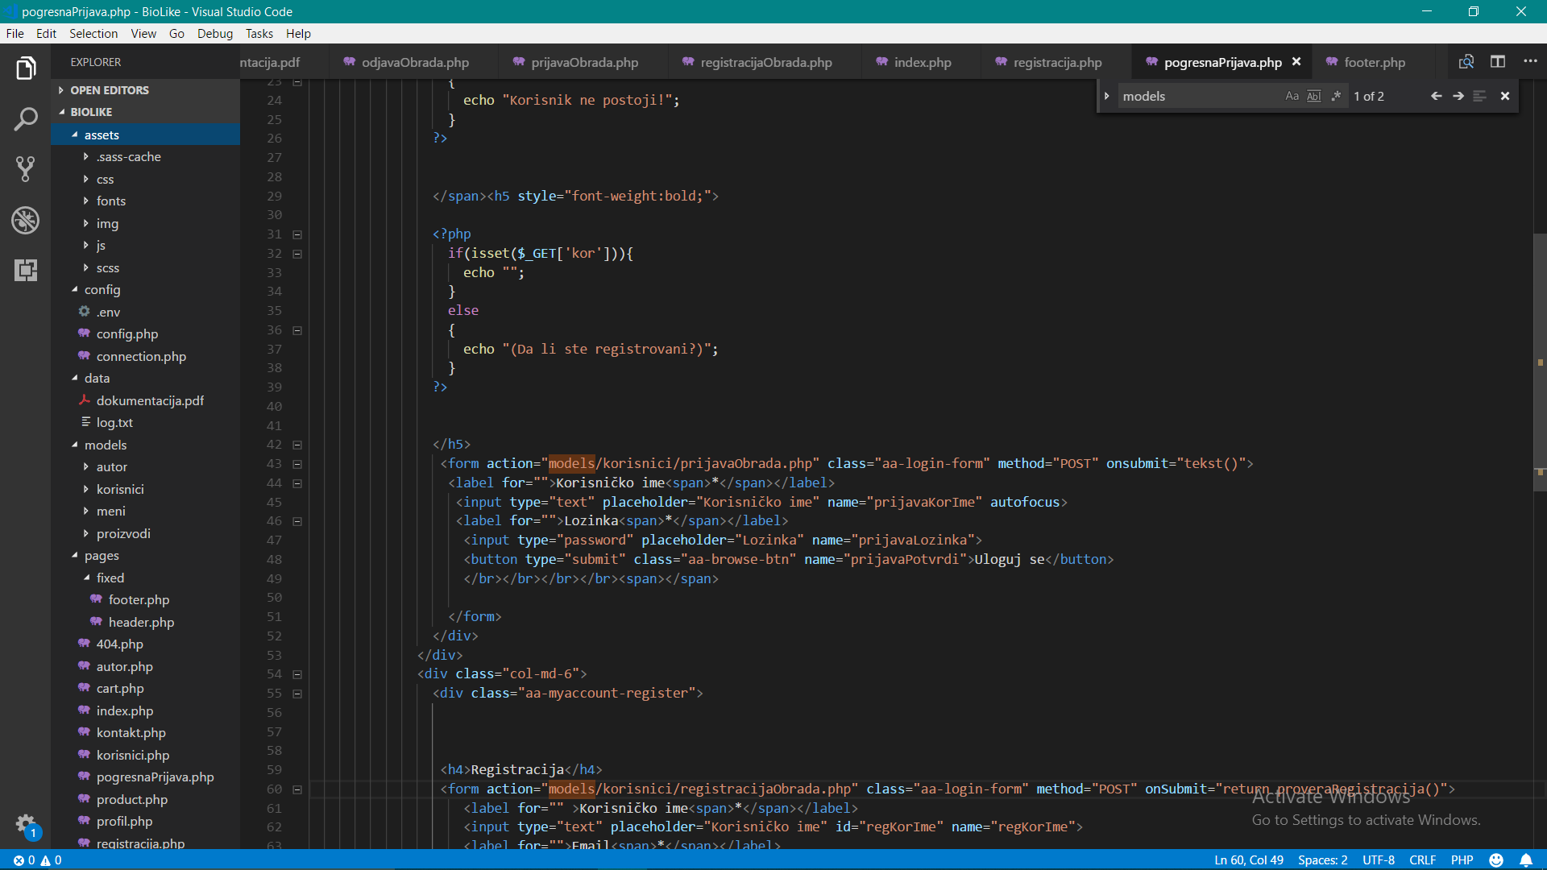

## Dizajin baze

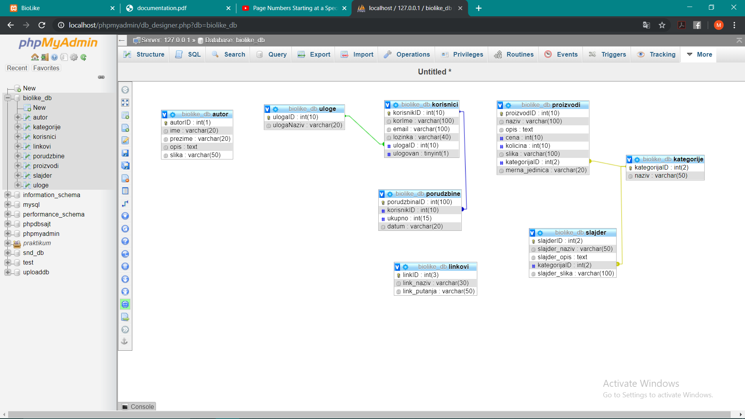

# KODOVI

## index.php

* <?php
* session_start();
* require_once("config/connection.php");
* include("pages/fixed/header.php");
* if(isset($_GET['stranica'])){
* $stranica = $_GET['stranica'];
* if($stranica=='index'){
* include "pages/index.php";
* } else if ($stranica == 'omiljeno') {
* include "pages/wishlist.php";
* } else if ($stranica == 'korpa') {
* include "pages/cart.php";
* }
* else if ($stranica == 'profil') {
* include "pages/profil.php";
* }
* else if ($stranica == 'registracija') {
* include "pages/registracija.php";
* }
* else if ($stranica == 'pogresnaPrijava') {
* include "pages/pogresnaPrijava.php";
* }
* else if ($stranica == 'proizvodi') {
* include "pages/product.php";
* }
* else if ($stranica == 'korisnici') {
* include "pages/korisnici.php";
* }
* else if ($stranica == 'greska') {
* include "pages/404.php";
* }
* else if ($stranica == 'kontakt') {
* include "pages/kontakt.php";
* }
* else if ($stranica == 'autor') {
* include "pages/autor.php";
* }
* else {
* include "pages/index.php";
* }
* }
* else
* {
* include "pages/index.php";
* }
* include("pages/fixed/footer.php");

## config/.env

DBNAME=biolike_db

SERVER=localhost

USERNAME=root

PASSWORD=

## config/config.php

* <?php
* define("BASE_URL", "http://localhost/BioLike/");
* define("ABSOLUTE_PATH", $_SERVER['DOCUMENT_ROOT']."/BioLike/");
* define("ENV_FAJL", ABSOLUTE_PATH."config/.env");
* define("LOG_FAJL", ABSOLUTE_PATH."data/log.txt");
* define("SERVER", env("SERVER"));
* define("DBNAME", env("DBNAME"));
* define("USERNAME", env("USERNAME"));
* define("PASSWORD", env("PASSWORD"));
* function env($naziv){
* $open=fopen(ENV_FAJL, 'r');
* $podaci=file(ENV_FAJL);
* // fclose(ENV_FAJL);
* $vrednost="";
* foreach($podaci as $podatak){
* $konfig=explode("=", $podatak);
* if($konfig[0]==$naziv){
* $vrednost=trim($konfig[1]);
* }
* }
* return $vrednost;
* }

## config/connection.php

* <?php
* require_once("config.php");
* // stranica();
* try{
* $konekcija = new PDO ("mysql:host=".SERVER.";dbname=".DBNAME.";charset=utf8;", USERNAME, PASSWORD);
* $konekcija -> setAttribute(PDO::ATTR_ERRMODE,PDO::ERRMODE_EXCEPTION);
* $konekcija -> setAttribute(PDO::ATTR_DEFAULT_FETCH_MODE,PDO::FETCH_OBJ);
* }
* catch(PDOException $e){
* echo $e -> getMessage();
* }
* // function stranica(){
* // $open=fopen(LOG_FAJL, "a");
* // if($open){
* // fwrite($open, "{$_SERVER['PHP_SELF']}\t{$_SERVER['REMOTE_ADDR']}\n");
* // }
* // fclose($open);
* // }

## models/autor/autorIspis.php

<?php

function autor(){

include "config/connection.php";

$upit="SELECT * FROM autor";

$rez=$konekcija->query($upit);

if($rez){

return $rez;

}

}

## models/autor/word.php

* <?php
* // include "../../config/connection.php";
* // $word = new COM("Word.Application");
* // $word->Visible = 1;
* // $word->Documents->Add();
* // $upit="SELECT * FROM autor";
* // $rezultat=$konekcija->query($upit);
* // if($rezultat){
* // $autor=$rezultat->fetch();
* // foreach($autor as $a){
* // $word->Selection->InlineShapes->AddPicture(ABSOLUTE_PATH."/assets/img/".$a->slika);
* // $word->Selection->TypeText("\n");
* // $word->Selection->TypeText("{$a->ime}\t");
* // $word->Selection->TypeText("{$a->prezime}\n");
* // $word->Selection->TypeText("{$a->opis}\n");
* // }
* // }
* // $imeFajla = "autor.doc";
* // $word->Documents[1]->SaveAs($imeFajla);
* // $word->Quit();
* // $word = null;
* // http_response_code(204);
* header('Location: ../../index.php?stranica=autor');

## models/korisnici/dodajKorisnika.php

<?php

include "../../config/connection.php";

if(isset($_POST['ime'])){

$ime=$_POST['ime'];

$email=$_POST['email'];

$lozinka=md5($_POST['lozinka']);

$uloga=$_POST['uloga'];

$upit="INSERT INTO korisnici VALUES(NULL,:ime,:email,:lozinka,:uloga,0)";

$pr=$konekcija->prepare($upit);

$pr->bindParam(':ime',$ime);

$pr->bindParam(':email',$email);

$pr->bindParam(':lozinka',$lozinka);

$pr->bindParam(':uloga',$uloga);

$pr->execute();

}

## models/korisnici/excel.php

* <?php
* // include "../../config/connection.php";
* // $excel_app = new COM("Excel.Application");
* // $excel_app->Visible = true;
* // $excel_file = $excel_app->Workbooks->Add();
* // $worksheet = $excel_file->Worksheets("Sheet1");
* // $worksheet->activate();
* // $field_A1 = $worksheet->Range("A1");
* // $field_A1->activate;
* // $field_A1->Value = "ID";
* // $field_B1 = $worksheet->Range("B1");
* // $field_B1->activate;
* // $field_B1->Value = "Korisnicko ime";
* // $field_C1 = $worksheet->Range("C1");
* // $field_C1->activate;
* // $field_C1->Value = "Email";
* // $field_D1 = $worksheet->Range("D1");
* // $field_D1->activate;
* // $field_D1->Value = "Lozinka";
* // $field_E1 = $worksheet->Range("E1");
* // $field_E1->activate;
* // $field_E1->Value = "Uloga";
* // $br = 2;
* // $upit="SELECT * FROM korisnici k INNER JOIN uloge u ON k.ulogaID=u.ulogaID ORDER BY u.ulogaID";
* // $rezultat=$konekcija->query($upit);
* // if($rezultat){
* // $korisnici=$rezultat->fetchAll();
* // foreach($korisnici as $kor){
* // $field_A = $worksheet->Range("A".$br);
* // $field_A->activate;
* // $field_A->Value = $kor->korisnikID;
* // $field_B = $worksheet->Range("B".$br);
* // $field_B->activate;
* // $field_B->Value = $kor->korIme;
* // $field_C = $worksheet->Range("C".$br);
* // $field_C->activate;
* // $field_C->Value = $kor->email;
* // $field_D = $worksheet->Range("D".$br);
* // $field_D->activate;
* // $field_D->Value = $kor->lozinka;
* // $field_E = $worksheet->Range("E".$br);
* // $field_E->activate;
* // $field_E->Value = $kor->ulogaNaziv;
* // $br++;
* // }
* // }
* // $fileName = "korisnici.xlsx";
* // $excel_file->SaveAs($fileName);
* // $excel_file->Close(false);
* // $excel_app->Workbooks->Close();
* // unset($worksheet);
* // $excel_app->Quit();
* // $excel_app = null;
* header('Location:../../index.php?stranica=greska');

## models/korisnici/izmeniKorisnika.php

* <?php
* include "../../config/connection.php";
* if(isset($_POST['id'])){
* $id=$_POST['id'];
* $ime=$_POST['ime'];
* $email=$_POST['email'];
* if(strlen($_POST['lozinka']>8)){
* $lozinka=$_POST['lozinka'];
* }
* else{
* $lozinka=md5($_POST['lozinka']);
* }
* $uloga=$_POST['uloga'];
* $upit="UPDATE korisnici SET korIme=:ime, email=:email, lozinka=:lozinka, ulogaID=:uloga WHERE korisnikID=:id";
* $pr=$konekcija->prepare($upit);
* $pr->bindParam(':ime',$ime);
* $pr->bindParam(':email',$email);
* $pr->bindParam(':lozinka',$lozinka);
* $pr->bindParam(':uloga',$uloga);
* $pr->bindParam(':id',$id);
* $pr->execute();
* var_dump($pr);
* }

## models/korisnici/korisniciIspis.php

<?php

function ispisiKorisnike(){

include "config/connection.php";

$upit="SELECT * FROM korisnici k INNER JOIN uloge u ON k.ulogaID=u.ulogaID ORDER BY u.ulogaID";

$rezultat=$konekcija->query($upit);

if($rezultat){

return $rezultat;

}

}

function brKorisnika(){

include "config/connection.php";

$upitBR="SELECT COUNT(*) AS brKor FROM korisnici";

$rezultatBR=$konekcija->query($upitBR);

if($rezultatBR){

return $rezultatBR;

}

}

function brUlogovanih(){

include "config/connection.php";

$upitUL="SELECT COUNT(*) AS brUL FROM korisnici WHERE ulogovan=1";

$rezultatUL=$konekcija->query($upitUL);

if($rezultatUL){

return $rezultatUL;

}

}

## models/korisnici/obrisiKorisnika.php

* <?php
* include "../../config/connection.php";
* if(isset($_POST['id'])){
* $id=$_POST['id'];
* $upit="DELETE FROM korisnici WHERE korisnikID=:id";
* $pr=$konekcija->prepare($upit);
* $pr->bindParam(':id',$id);
* $pr->execute();
* }

## models/korisnici/odjavaObrada.php

<?php

session_start();

if(isset($_SESSION['korisnik'])){

include "../../config/connection.php";

$upit="UPDATE korisnici SET ulogovan=0 WHERE korisnikID=:id";

$rezultat=$konekcija->prepare($upit);

$rezultat->bindParam(':id',$_SESSION['korisnik']->korisnikID);

$rezultat->execute();

unset($_SESSION['korisnik']);

unset($_SESSION['korpa']);

header("Location:../../index.php?stranica=index");

}

## models/korisnici/prijavaObrada.php

* <?php
* session_start();
* include('../../config/connection.php');
* if(isset($_POST['prijavaPotvrdi'])){
* $korIme=$_POST['prijavaKorIme'];
* $lozinka=md5($_POST['prijavaLozinka']);
* $upit="SELECT * FROM korisnici WHERE korIme=:korisnicko AND lozinka=:pass";
* $priprema=$konekcija->prepare($upit);
* $priprema -> bindParam(":korisnicko",$korIme);
* $priprema -> bindParam(":pass",$lozinka);
* $rezultat= $priprema->execute();
* if($rezultat){
* if($priprema->rowCount()==1){
* $korisnik = $priprema->fetch();
* $_SESSION['korisnik']=$korisnik;
* $upit2="UPDATE korisnici SET ulogovan=1 WHERE korisnikID=:id";
* $rezultat=$konekcija->prepare($upit2);
* $rezultat->bindParam(':id',$_SESSION['korisnik']->korisnikID);
* $rezultat->execute();
* header("Location:../../index.php?stranica=index");
* }
* else{
* $upit3="SELECT * FROM korisnici WHERE korIme=:ime";
* $priprema3=$konekcija->prepare($upit3);
* $priprema3 -> bindParam(":ime",$korIme);
* $rezultat3=$priprema3->execute();
* if($rezultat3){
* if($priprema3->rowCount()==1){
* $to = 'milanzlatanovic97@hotmail.rs';
* $subject = 'Pogresna lozinka';
* $message = 'Poštovani, na našem sajtu je iskorišćeno Vaše korisničko ime prilikom neuspele prijave. Da li ste to bili Vi?';
* $headers = 'From: xmix97@live.com' . "\r\n" .
* 'Reply-To: xmix97@live.com' . "\r\n" .
* 'X-Mailer: PHP/' . phpversion();
* mail($to, $subject, $message, $headers);
* header("Location:../../index.php?stranica=pogresnaPrijava&&kor");
* }
* else
* {
* header("Location:../../index.php?stranica=pogresnaPrijava");
* }

* }
* }

* }

* }



* // if(isset($_POST['prijavaPotvrdi2'])){
* // $korIme=$_POST['prijavaKorIme'];
* // $lozinka=md5($_POST['prijavaLozinka']);
* // $upit="SELECT * FROM korisnici WHERE korIme=:korisnicko AND lozinka=:pass";
* // $priprema=$konekcija->prepare($upit);
* // $priprema -> bindParam(":korisnicko",$korIme);
* // $priprema -> bindParam(":pass",$lozinka);
* // $rezultat= $priprema->execute();
* // if($rezultat){
* // if($priprema->rowCount()==1){
* // $korisnik = $priprema->fetch();
* // $_SESSION['korisnik']=$korisnik;
* // header("Location:../../index.php?stranica=index");
* // }
* // }
* // }

## models/korisnici/registracijaObrada.php

<?php

include('../../config/connection.php');

if(isset($_POST['regPotvrdi'])){

$korIme=$_POST['regKorIme'];

$email=$_POST['regEmail'];

$lozinka=md5($_POST['regLozinka']);

        $lozinkaP=md5($_POST['regLozinkaP']);

$korImeProvera = "/^[A-ZČĆŠĐŽa-zčćšđž0-9]{7,20}$/";

$emailProvera = "/^[a-zA-Z0-9-_.]+@[a-zA-Z0-9]+(?:\.[a-zA-Z0-9]+)*$/";

$lozinkaProvera = "/^(?=.*[A-Za-z])(?=.*\d)[A-Za-z\d]{8,}$/";

$nizIspravno = [];

$nizGreske = [];

if(preg_match($korImeProvera,$korIme)){

array_push($nizIspravno, $korIme);

}

else

{

array_push($nizGreske,"korIme");

}

if(preg_match($emailProvera,$email)){

array_push($nizIspravno, $email);

}

else

{

array_push($nizGreske,"Email");

}

if(preg_match($lozinkaProvera, $lozinka)){

array_push($nizIspravno, $lozinka);

}

else

{

array_push($nizGreske,"Lozinka");

}

if($lozinkaP!=$lozinka){

array_push($nizGreske,"LozinkaPotvrdi");

}

else

{

array_push($nizIspravno,"Potvrdjeno");

}

if(count($nizGreske)==0){

$upisKorisnika="INSERT INTO korisnici VALUES (NULL,:ime,:mail,:pass,'2')";

$priprema = $konekcija -> prepare($upisKorisnika);

$priprema -> bindParam(':ime',$korIme);

$priprema -> bindParam(':mail',$email);

$priprema -> bindParam(':pass',$lozinka);

$priprema -> execute();

header("Location:../../index.php?stranica=index");

}

else

{

header("Location:../../index.php?stranica=greska");

}

}

?>

## models/proizvodi/ispisKategorija.php

* <?php
* function ispisKat(){
* include ("config/connection.php");
* $katUpit="SELECT * FROM kategorije";
* $rezultat=$konekcija->query($katUpit);
* if($rezultat){
* return $rezultat;
* }
* }

## models/korisnici/ispisPorudzbina.php

<?php

function porudzIspis(){

include "config/connection.php";

if(isset($_SESSION['korisnik'])){

$korID=$_SESSION['korisnik']->korisnikID;

if($_SESSION['korisnik']->ulogaID==2){

$upit="SELECT * FROM porudzbine p INNER JOIN korisnici k ON p.korisnikID=k.korisnikID WHERE k.korisnikID=$korID ORDER BY porudzbinaID DESC";

$rezultat=$konekcija->query($upit);

if($rezultat){

return $rezultat;

}

}

else

{

$upit="SELECT * FROM porudzbine p INNER JOIN korisnici k ON p.korisnikID=k.korisnikID ORDER BY porudzbinaID DESC";

$rezultat=$konekcija->query($upit);

if($rezultat){

return $rezultat;

}

}

}

}

function proudzUkupno(){

include "config/connection.php";

$upitUkupno="SELECT COUNT(*) AS ukupanBR, SUM(ukupno) AS iznos FROM porudzbine";

$ukupno=$konekcija->query($upitUkupno);

if($ukupno){

return $ukupno;

}

}

## models/proizvodi/ispisProizvoda.php

* <?php

* // FILTER
* if(isset($_GET['sort'])){
* include ("../../config/connection.php");
* $sort=$_GET['sort'];
* header("Content-type: application/json");
* if($sort==1){
* $upit="SELECT *, p.naziv AS ime FROM proizvodi p INNER JOIN kategorije k ON p.kategorijaID=k.kategorijaID";
* $rezultat=$konekcija->query($upit);
* $podaci=$rezultat->fetchAll();
* echo json_encode($podaci);
* http_response_code(200);
* }
* elseif($sort==2){
* $upit="SELECT *, p.naziv AS ime FROM proizvodi p INNER JOIN kategorije k ON p.kategorijaID=k.kategorijaID ORDER BY ime";
* $rezultat=$konekcija->query($upit);
* $podaci=$rezultat->fetchAll();
* echo json_encode($podaci);
* http_response_code(200);
* }
* elseif($sort==3){
* $upit="SELECT *, p.naziv AS ime FROM proizvodi p INNER JOIN kategorije k ON p.kategorijaID=k.kategorijaID ORDER BY ime DESC";
* $rezultat=$konekcija->query($upit);
* $podaci=$rezultat->fetchAll();
* echo json_encode($podaci);
* http_response_code(200);
* }
* elseif($sort==4){
* $upit="SELECT *, p.naziv AS ime FROM proizvodi p INNER JOIN kategorije k ON p.kategorijaID=k.kategorijaID ORDER BY cena";
* $rezultat=$konekcija->query($upit);
* $podaci=$rezultat->fetchAll();
* echo json_encode($podaci);
* http_response_code(200);
* }
* elseif($sort==5){
* $upit="SELECT *, p.naziv AS ime FROM proizvodi p INNER JOIN kategorije k ON p.kategorijaID=k.kategorijaID ORDER BY cena DESC";
* $rezultat=$konekcija->query($upit);
* $podaci=$rezultat->fetchAll();
* echo json_encode($podaci);
* http_response_code(200);
* }
* }
* elseif(isset($_GET['src'])){
* include "../../config/connection.php";
* $src=$_GET['src'];
* $src = "%".strtolower($src)."%";
* $upit="SELECT *, p.naziv AS ime FROM proizvodi p INNER JOIN kategorije k ON p.kategorijaID=k.kategorijaID WHERE p.naziv LIKE '%$src%'";
* $rezultat=$konekcija->query($upit);
* $podaci=$rezultat->fetchAll();
* echo json_encode($podaci);
* http_response_code(200);
* }

* function ispisProizvoda(){
* include "config/connection.php";
* if(isset($_GET['id'])&&$_GET['id']!=0){
* $kat=$_GET['id'];
* $upit="SELECT *, p.naziv AS ime FROM proizvodi p INNER JOIN kategorije k ON p.kategorijaID=k.kategorijaID WHERE p.kategorijaID=$kat";
* $rezultat=$konekcija->query($upit);
* return $rezultat;
* }
* else{
* $upit2="SELECT *, p.naziv AS ime FROM proizvodi p INNER JOIN kategorije k ON p.kategorijaID=k.kategorijaID";
* $rezultat=$konekcija->query($upit2);
* return $rezultat;
* }


* }

## models/proizvodi/izbrišiProizvod.php

<?php

include '../../config/connection.php';

if(isset($_GET['id'])){

$id=$_GET['id'];

$upit="DELETE FROM proizvodi WHERE proizvodID=:nesto";

$priprema=$konekcija->prepare($upit);

$priprema->bindParam('nesto',$id);

$rezultat=$priprema->execute();

header('Location: ../../index.php?stranica=proizvodi&&strana=1#proizvodi');

}

## models/proizvodi/izmeniProizvod.php

* <?php
* include "../../config/connection.php";
* if(isset($_POST{'id'})){
* $id=$_POST['id'];
* $naziv=$_POST['naziv'];
* $opis=$_POST['opis'];
* $cena=$_POST['cena'];
* $kol=$_POST['kol'];
* $kat=$_POST['kat'];
* $mera=$_POST['mera'];
* $upit="UPDATE proizvodi SET naziv=:naziv,opis=:opis,cena=:cena,kolicina=:kol,kategorijaID=:kat,merna_jedinica=:mera WHERE proizvodID=:id";
* $priprema=$konekcija->prepare($upit);
* $priprema->bindParam(':id',$id);
* $priprema->bindParam(':naziv',$naziv);
* $priprema->bindParam(':opis',$opis);
* $priprema->bindParam(':cena',$cena);
* $priprema->bindParam(':kol',$kol);
* $priprema->bindParam(':kat',$kat);
* $priprema->bindParam(':mera',$mera);
* $rezultat=$priprema->execute();
* }

## models/proizvodi/izracunajCenu.php

<?php

if(isset($_POST['kolicina'])&&isset($_POST['id'])){

$id=$_POST['id'];

$kol=$_POST['kolicina'];

include "../../config/connection.php";

$upit="SELECT cena, proizvodID FROM proizvodi WHERE proizvodID=$id";

$rezultat=$konekcija->query($upit);

if($rezultat){

$podatak=$rezultat->fetch();

$pod=$podatak->cena;

$ukupno = $pod*$kol;

print_r($ukupno);

echo json_encode([$ukupno,$id]);

}

}

## models/proizvodi/korpa.php

* <?php
* session_start();
* if(isset($_POST['korpaPotvrdi'])){
* $id=$_POST['skrivenoId'];
* $naziv=$_POST['skrivenoNaziv'];
* $opis=$_POST['skrivenoOpis'];
* $cena=$_POST['skrivenoCena'];
* $jedMere=$_POST['skrivenoJM'];
* $korpa=['id'=>$id,'naziv'=>$naziv,'opis'=>$opis,'cena'=>$cena,'jedMere'=>$jedMere];
* $_SESSION['korpa'][]=$korpa;
* header('Location:../../index.php?stranica=proizvodi&&strana=1');
* }

## models/proizvodi/obrisiKorpu.php

<?php

session_start();

if(isset($_SESSION['korpa'])){

unset($_SESSION['korpa']);

header("Location:../../index.php?stranica=korpa");

}

## models/proizvodi/obrisiProizvodKorpa.php

* <?php
* session_start();
* if(isset($_GET['rb'])){
* $rb=$_GET['rb'];
* unset($_SESSION['korpa'][$rb]);
* if(count($_SESSION['korpa'])<1){
* unset($_SESSION['korpa']);
* }
* header("Location:../../index.php?stranica=korpa");
* }

## models/proizvodi/poruci.php

<?php

session_start();

include "../../config/connection.php";

if(isset($_SESSION['korisnik'])){

$kor=$_SESSION['korisnik']->korisnikID;

if(isset($_POST['ukupno'])){

$ukupno=$_POST['ukupno'];

$datum=date('d.m.Y H:i:s');

$upit="INSERT INTO porudzbine VALUES (NULL,:kor,:ukupno,:datum)";

$pr=$konekcija->prepare($upit);

$pr->bindParam(':kor',$kor);

$pr->bindParam(':ukupno',$ukupno);

$pr->bindParam(':datum',$datum);

$pr->execute();

unset($_SESSION['korpa']);

}

}

## pages/fixed/header.php

* <!DOCTYPE html>
* <html lang="en">
* <head>
* <meta charset="utf-8">
* <meta http-equiv="X-UA-Compatible" content="IE=edge">
* <meta name="viewport" content="width=device-width, initial-scale=1">
* <title>BioLike <?php
* if(isset($_GET['stranica'])){
* $stranicaNaslov=$_GET['stranica'];
* if($stranicaNaslov=='index'){
* echo '';
* }
* else if($stranicaNaslov=='korpa'){
* echo '| Korpa';
* }
* else if($stranicaNaslov=='profil'){
* echo '| Prijava';
* }
* else if($stranicaNaslov=='proizvodi'){
* echo '| Proizvodi';
* }
* else{
* echo '';
* }
* }
* ?></title>
* <!-- Font awesome -->
* <link href="assets/css/font-awesome.css" rel="stylesheet">
* <!-- Bootstrap -->
* <link href="assets/css/bootstrap.css" rel="stylesheet">
* <!-- SmartMenus jQuery Bootstrap Addon CSS -->
* <link href="assets/css/jquery.smartmenus.bootstrap.css" rel="stylesheet">
* <!-- Product view slider -->
* <link rel="stylesheet" type="text/css" href="assets/css/jquery.simpleLens.css">
* <!-- slick slider -->
* <link rel="stylesheet" type="text/css" href="assets/css/slick.css">
* <!-- price picker slider -->
* <link rel="stylesheet" type="text/css" href="assets/css/nouislider.css">
* <!-- Theme color -->
* <link id="switcher" href="assets/css/theme-color/bridge-theme.css" rel="stylesheet">
* <!-- <link id="switcher" href="css/theme-color/bridge-theme.css" rel="stylesheet"> -->
* <!-- Top Slider CSS -->
* <link href="assets/css/sequence-theme.modern-slide-in.css" rel="stylesheet" media="all">
* <!-- Main style sheet -->
* <link href="assets/css/style.css" rel="stylesheet">
* <!-- Google Font -->
* <link href='https://fonts.googleapis.com/css?family=Lato' rel='stylesheet' type='text/css'>
* <link href='https://fonts.googleapis.com/css?family=Raleway' rel='stylesheet' type='text/css'>
* <!-- HTML5 shim and Respond.js for IE8 support of HTML5 elements and media queries -->
* <!-- WARNING: Respond.js doesn't work if you view the page via file:// -->
* <!--[if lt IE 9]>
* <script src="https://oss.maxcdn.com/html5shiv/3.7.2/html5shiv.min.js"></script>
* <script src="https://oss.maxcdn.com/respond/1.4.2/respond.min.js"></script>
* <![endif]-->
* </head>
* <body>
* <!-- wpf loader Two -->
* <!-- <div id="wpf-loader-two">
* <div class="wpf-loader-two-inner">
* <span>Učitavanje</span>
* </div>
* </div> -->
* <!-- / wpf loader Two -->
* <!-- SCROLL TOP BUTTON -->
* <a class="scrollToTop" href="#"><i class="fa fa-chevron-up"></i></a>
* <!-- END SCROLL TOP BUTTON -->
* <!-- Start header section -->
* <header id="aa-header">
* <!-- start header top -->
* <div class="aa-header-top">
* <div class="container">
* <div class="row">
* <div class="col-md-12">
* <div class="aa-header-top-area">
* <!-- start header top left -->
* <div class="aa-header-top-left">
* <!-- start language -->
* <!-- / language -->
* <!-- start currency -->
* <!-- / currency -->
* <!-- start cellphone -->
* <div class="cellphone hidden-xs">
* <p><span class="fa fa-phone"></span>+381 64 1234 567</p>
* </div>
* <!-- / cellphone -->
* </div>
* <!-- / header top left -->
* <div class="aa-header-top-right">
* <ul class="aa-head-top-nav-right">
* <?php
* if(isset($_SESSION['korisnik'])&&$_SESSION['korisnik']->ulogaID==1){
* echo "<li><a href='index.php?stranica=korisnici'>Korisnici</a></li>
* <li><a href='data/log.txt' target='_blank'>log.txt</a></li>
* <li><a href='index.php?stranica=profil'>".$_SESSION['korisnik']->korIme."</a></li>
* ";
* }
* elseif(isset($_SESSION['korisnik'])){
* echo "<li><a href='index.php?stranica=profil'>".$_SESSION['korisnik']->korIme."</a></li>";
* }
* else{
* echo "";
* }
* ?>
* <li class="hidden-xs"><a href="index.php?stranica=korpa">Korpa</a></li>
* <?php
* if(isset($_SESSION['korisnik'])){
* echo "<li><a href='models/korisnici/odjavaObrada.php' name='odjava' id='odjava'>Odjavi se</a></li>";
* }
* else{
* echo "<li><a href='' data-toggle='modal' data-target='#login-modal'>Prijavite se</a></li>";
* }
* ?>
* </ul>
* </div>
* </div>
* </div>
* </div>
* </div>
* </div>
* <!-- / header top -->
* <!-- start header bottom -->
* <div class="aa-header-bottom">
* <div class="container">
* <div class="row">
* <div class="col-md-12">
* <div class="aa-header-bottom-area">
* <!-- logo -->
* <div class="aa-logo">
* <!-- Text based logo -->
* <a href="index.php?stranica=index">
* <p>bio<strong>like</strong> <span>zdrava hrana</span></p>
* </a>
* <!-- img based logo -->
* <!-- <a href="index.html"><img src="img/logo.jpg" alt="logo img"></a> -->
* </div>
* <!-- / logo -->
* <!-- cart box -->
* <div class="aa-cartbox">
* <a class="aa-cart-link" href="#">
* <span class="fa fa-shopping-basket"></span>
* <span class="aa-cart-title">KORPA</span>
* <span class="aa-cart-notify"><?php
* if(isset($_SESSION['korpa'])){
* $brukorpi=count($_SESSION['korpa']);
* echo $brukorpi;}
* else{
* echo "0";
* }
* ?></span>
* </a>
* <div class="aa-cartbox-summary">
* <ul>
* <?php
* if(isset($_SESSION['korpa'])):
* foreach($_SESSION['korpa'] as $pod):
* ?>
* <li>
* <div class="aa-cartbox-info">
* <h4><a href="#"><?= $pod['naziv']; ?></a></h4>
* <p><?= $pod['cena']; ?>din.</p>
* </div>
* <a class="aa-remove-product" href="#"><span class="fa fa-times"></span></a>
* </li>
* <?php endforeach; ?>
* <?php else: echo "";
* endif;
* ?>
* </ul>
* <?php
* if(isset($_SESSION['korpa'])){
* echo "<a class='aa-cartbox-checkout aa-primary-btn' href='index.php?stranica=korpa'>Pogledaj</a>";
* }
* else
* {
* echo "Korpa je prazna";
* }
* ?>
* </div>
* </div>
* <!-- / cart box -->
* <!-- search box -->
* <!-- / search box -->
* </div>
* </div>
* </div>
* </div>
* </div>
* <!-- / header bottom -->
* </header>
* <!-- / header section -->
* <!-- menu -->
* <section id="menu">
* <div class="container">
* <div class="menu-area">
* <!-- Navbar -->
* <div class="navbar navbar-default" role="navigation">
* <div class="navbar-header">
* <button type="button" class="navbar-toggle" data-toggle="collapse" data-target=".navbar-collapse">
* <span class="sr-only">Toggle navigation</span>
* <span class="icon-bar"></span>
* <span class="icon-bar"></span>
* <span class="icon-bar"></span>
* </button>
* </div>
* <div class="navbar-collapse collapse">
* <!-- Left nav -->
* <ul class="nav navbar-nav">
* <?php
* include "models/meni/linkoviIspis.php";
* $li=linkoviIspis();
* foreach($li as $link):
* ?>
* <li><a href="<?= $link->link_putanja ?>"><?= $link->link_naziv ?></a></li>
* <?php endforeach; ?>
* </ul>
* </div><!--/.nav-collapse -->
* </div>
* </div>
* </div>
* </section>
* <!-- / menu -->

## pages/fixed/footer.php

<!-- footer -->

<footer id="aa-footer">

<!-- footer bottom -->

<div class="aa-footer-top">

<div class="container">

<div class="row">

<div class="col-md-12">

<div class="aa-footer-top-area">

<div class="row">

<div class="col-md-3 col-sm-6">

<div class="aa-footer-widget">

<h3>Main Menu</h3>

<ul class="aa-footer-nav">

<?php

$lin=linkoviIspis();

foreach($lin as $link):

?>

<li><a href="<?= $link->link_putanja ?>"><?= $link->link_naziv ?></a></li>

<?php endforeach; ?>

</ul>

</div>

</div>

<div class="col-md-3 col-sm-6">

<div class="aa-footer-widget">

<div class="aa-footer-widget">

<h3>Korisni linkovi</h3>

<ul class="aa-footer-nav">

<li><a href="data/dokumentacija.pdf" target="_blank">Dokumentacija</a></li>

</ul>

</div>

</div>

</div>

<div class="col-md-3 col-sm-6">

<div class="aa-footer-widget">

<div class="aa-footer-widget">

<h3>Kontaktirajte nas</h3>

<address>

<p>Aleksandra Vojinovića 56, Resnik-Beograd</p>

<p><span class="fa fa-phone"></span>+381 64 1234 567</p>

<p><span class="fa fa-envelope"></span>biolike@gmail.com</p>

</address>

<div class="aa-footer-social">

<a href="#"><span class="fa fa-facebook"></span></a>

<a href="#"><span class="fa fa-twitter"></span></a>

<a href="#"><span class="fa fa-google-plus"></span></a>

<a href="#"><span class="fa fa-youtube"></span></a>

</div>

</div>

</div>

</div>

</div>

</div>

</div>

</div>

</div>

</div>

<!-- footer-bottom -->

<div class="aa-footer-bottom">

<div class="container">

<div class="row">

<div class="col-md-12">

<div class="aa-footer-bottom-area">

<p>Autor: <a href="index.php?stranica=autor">Zlatanovic Milan 158/16</a></p>

<div class="aa-footer-payment">

<span class="fa fa-cc-mastercard"></span>

<span class="fa fa-cc-visa"></span>

<span class="fa fa-paypal"></span>

<span class="fa fa-cc-discover"></span>

</div>

</div>

</div>

</div>

</div>

</div>

</footer>

<!-- / footer -->

<!-- Login Modal -->

<div class="modal fade" id="login-modal" tabindex="-1" role="dialog" aria-labelledby="myModalLabel" aria-hidden="true">

<div class="modal-dialog">

<div class="modal-content">

<div class="modal-body">

<button type="button" class="close" data-dismiss="modal" aria-hidden="true">&times;</button>

<h4>Prijava / Registracija</h4>

<form action="models/korisnici/prijavaObrada.php" class="aa-login-form" method="POST">

<label for="">Korisničko ime<span>*</span></label>

<input type="text" placeholder="Korisničko ime" name="prijavaKorIme">

<label for="">Lozinka<span>*</span></label>

<input type="password" placeholder="Lozinka" name="prijavaLozinka">

<button class="aa-browse-btn" type="submit" name='prijavaPotvrdi'>Login</button>

<div class="aa-register-now">

Niste registrovani?<a href="index.php?stranica=registracija">Registrujte se sada!</a>

</div>

</form>

</div>

</div><!-- /.modal-content -->

</div><!-- /.modal-dialog -->

</div>

<!-- jQuery library -->

<script src="https://ajax.googleapis.com/ajax/libs/jquery/1.11.3/jquery.min.js"></script>

<!-- Include all compiled plugins (below), or include individual files as needed -->

<script src="assets/js/bootstrap.js"></script>

<!-- SmartMenus jQuery plugin -->

<script type="text/javascript" src="assets/js/jquery.smartmenus.js"></script>

<!-- SmartMenus jQuery Bootstrap Addon -->

<script type="text/javascript" src="assets/js/jquery.smartmenus.bootstrap.js"></script>

<!-- To Slider JS -->

<script src="assets/js/sequence.js"></script>

<script src="assets/js/sequence-theme.modern-slide-in.js"></script>

<!-- Product view slider -->

<script type="text/javascript" src="assets/js/jquery.simpleGallery.js"></script>

<script type="text/javascript" src="assets/js/jquery.simpleLens.js"></script>

<!-- slick slider -->

<script type="text/javascript" src="assets/js/slick.js"></script>

<!-- Price picker slider -->

<script type="text/javascript" src="assets/js/nouislider.js"></script>

<!-- Custom js -->

<script src="assets/js/custom.js"></script>

<?php if(isset($_SESSION['korpa'])){

echo "<script type='text/javascript'>

$(document).ready(function(){

$('#odjava').click(function(){

var potvrdiOdjavu=confirm('Ukoliko se odjavite stavke iz vase korpe ce biti ponistene!');

if(potvrdiOdjavu == true){

return true;

}

else

{

return false;

}

});

});

</script>";

} ?>

<script type="text/javascript">

$(document).ready(function(){

$('.obrisi').click(function(){

var korID=$(this).data('obrisiid');

$.ajax({

url:'models/korisnici/obrisiKor.php',

method:'POST',

type:'json',

data:{

id:korID

},

success:function(){

window.location.replace("http://localhost/BioLike/index.php?stranica=korisnici");

}

});

});

// $('.izmeniKor').click(function(){

// var korIzm=$(this).data('izmeni');

// var korIme=$('#korIme').val();

// console.log(korIme);

// var email=$('#korEmail').val();

// console.log(email);

// var lozinka=$('#korPass').val();

// console.log(lozinka);

// var uloga=$('#korUl :checked').val();

// console.log(lozinka);

// $.ajax({

// url:'models/korisnici/izmeniKorisnika.php',

// method:'POST',

// type:'json',

// data:{

// id:korIzm,

// ime:korIme,

// email:email,

// lozinka:lozinka,

// uloga:uloga

// },

// success:function(){

// // window.location.replace("http://localhost/BioLike/index.php?stranica=korisnici");

// }

// });

// });

$('#dodajKorDugme').click(function(){

var dodajIme=$('#dodajIme').val();

var dodajEmail=$('#dodajEmail').val();

var dodajLozinka=$('#dodajLozinka').val();

var dodajUloga=$('#dodajUloga :checked').val();

$.ajax({

url:'models/korisnici/dodajKorisnika.php',

method:'POST',

type:'json',

data:{

ime:dodajIme,

email:dodajEmail,

lozinka:dodajLozinka,

uloga:dodajUloga

},

success:function(){

window.location.replace("http://localhost/BioLike/index.php?stranica=korisnici");

}

});

});

// $("#button").click(function() {

// $('html, body').animate({

// scrollTop: $("#myDiv").offset().top

// }, 2000);

// });

$('.aa-cart-quantity').change(function(){

let nizKolicina=[];

let nizCena=[];

$('.cenaKorpa').each(function(){

let cena=$(this).text();

nizCena.push(cena);

});

$('.aa-cart-quantity').each(function(){

let kolicina = $(this).val();

nizKolicina.push(kolicina);

});

let nizZbir=nizCena.map(function(x,y){

return x * nizKolicina[y];

});

let nizZbirNovo=[];

$('.ukupnoKorpa').each(function(){

let vrednost=$(this).val();

nizZbirNovo.push(vrednost);

});

Array.prototype.splice.apply(nizZbirNovo, [0, nizZbir.length].concat(nizZbir));

let nizZbirNovoSum=0;

for(var i=0; i<nizZbirNovo.length; i++){

nizZbirNovoSum+=nizZbirNovo[i];

}

console.log(nizZbirNovoSum);

$('.ukupnoBezPDV').text(nizZbirNovoSum-(nizZbirNovoSum*20/100));

$('.ukupnoSaPDV').text(nizZbirNovoSum);

});

$('.izmeniPr').click(function(e){

e.preventDefault();

let proID=$('#proSkriveno').data('id');

let proNaziv=$('#proNaziv').val();

let proOpis=$('#proOpis').val();

let proCena=$('#proCena').val();

let proKol=$('#proKol').val();

let izmeniKat=$('#izmeniKat').find(':selected').val();

let izmeniMeru=$('#izmeniMeru').find(':selected').val();

$.ajax({

url:'models/proizvodi/izmeniProizvod.php',

method:'POST',

type:'json',

data:{

id:proID,

naziv:proNaziv,

opis:proOpis,

cena:proCena,

kol:proKol,

kat:izmeniKat,

mera:izmeniMeru

},

success:function(){

window.location.replace("http://localhost/BioLike/index.php?stranica=proizvodi&&strana=1");

}

});

});

$('.sortiraj').change(function(e){

e.preventDefault();

var sort=$(this).val();

$.ajax({

url:'models/proizvodi/ispisProizvoda.php',

method:'GET',

dataType:'json',

data:{

sort:sort

},

success:function(sortirani){

ispisPr(sortirani);

}

});

});

$('#pretraga').keyup(function(e){

e.preventDefault();

var src=$(this).val();

$.ajax({

url:'models/proizvodi/ispisProizvoda.php',

method:'GET',

dataType:'json',

data:{

src:src

},

success:function(sortirani){

ispisPr(sortirani);

}

});

});

$('#poruciDugme').click(function(){

var ukupno=$('.ukupnoSaPDV').text();

$.ajax({

url:'models/proizvodi/poruci.php',

method:'POST',

type:'json',

data:{

ukupno:ukupno

},

success:function(){

window.location.replace("http://localhost/BioLike/index.php?stranica=profil");

}

});

});

});

function ispisPr(sortirani){

html="";

for(let sortiran of sortirani){

html+=htmlSort(sortiran);

}

$('.aa-product-catg').html(html);

}

function htmlSort(sortiran){

return ` <li>

<form action="models/proizvodi/korpa.php" method="POST">

<figure>

<a class="aa-product-img" href="#"><img style="height:300px; width:260px;" src="${sortiran.slika}" alt="${sortiran.ime}"></a>

<input style='width:100%; border:0px; opacity:0.9' type='submit' class='aa-add-card-btn' value='Dodaj u korpu' name='korpaPotvrdi'/>

<input type='hidden' value='${sortiran.proizvodID}' name='skrivenoId'>

<input type='hidden' value='${sortiran.ime}' name='skrivenoNaziv'>

<input type='hidden' value='${sortiran.cena}' name='skrivenoCena'>

<input type='hidden' value='${sortiran.opis}' name='skrivenoOpis'>

<input type='hidden' value='${sortiran.merna_jedinica}' name='skrivenoJM'>

<figcaption>

<h4 class="aa-product-title"><a href="#" value=''>${sortiran.ime}</a></h4>

<span class="aa-product-price">${sortiran.cena}din.</span>

<p class="aa-product-descrip">${sortiran.opis}</p>

<?php

if(isset($_SESSION['korisnik'])&&$_SESSION['korisnik']->ulogaID==1):

?>

<br/><a class='izbrisiProizvod' style='color:red; font-style:italic;' href='models/proizvodi/izbrisiProizvod.php?id=${sortiran.proizvodID}'>Ukloni </a>/

<a class='izmeniProizvod' style='color:red; font-style:italic;' href='index.php?stranica=proizvodi&&id=${sortiran.proizvodID}&&strana=1#izmeniProizvod' data-id="${sortiran.proizvodID}">Izmeni</a>

<?php endif; ?>

</figcaption>

</figure>

<!-- product badge -->

<span class='aa-badge aa-sale' href='#'> ${sortiran.merna_jedinica} </span>

</form>

</li>`;

}

function proveraRegistracija(){

var korIme=document.querySelector('#regKorIme').value.trim();

var email=document.querySelector('#regEmail').value;

var lozinka=document.querySelector('#regLozinka').value;

var lozinkaP=document.querySelector('#regLozinkaP').value;

var korImeProvera = /^[A-ZČĆŠĐŽa-zčćšđž0-9]{7,20}$/;

var emailProvera = /^[a-zA-Z0-9-_.]+@[a-zA-Z0-9]+(?:\.[a-zA-Z0-9]+)*$/;

var lozinkaProvera = /^(?=.*[A-Za-z])(?=.*\d)[A-Za-z\d]{8,}$/;

var regIspravno = [];

var regGreske = [];

if(korImeProvera.test(korIme)){

regIspravno.push(korIme);

document.querySelector("#regKorIme").style.borderColor="#ddd";

}

else

{

regGreske.push("KORime");

document.querySelector("#regKorIme").style.borderColor="red";

}

if(emailProvera.test(email)){

regIspravno.push(email);

}

else

{

regGreske.push("email");

}

if(lozinkaProvera.test(lozinka)){

regIspravno.push(lozinka);

}

else

{

regGreske.push("lozinka");

}

if(lozinkaP!=lozinka){

regGreske.push("LozinkaP");

}

else

{

regIspravno.push("Potvrdjeno");

}

if(regGreske.length!=0){

return false;

}

else{

return true;

}

}

</script>

</body>

</html>

## pages/404.php

* <!-- 404 error section -->
* <section id="aa-error">
* <div class="container">
* <div class="row">
* <div class="col-md-12">
* <div class="aa-error-area">
* <h2>404</h2>
* <span>Izvinjavamo se! Stranica nije pronađena.</span>
* <a href="index.php?stranica=index">Povratak na početnu stranu</a>
* </div>
* </div>
* </div>
* </div>
* </section>
* <!-- / 404 error section -->

## pages/autor.php

* <!-- Cart view section -->
* <section id="cart-view">
* <div class="container">
* <div class="row">
* <div class="col-md-12">
* <div style="text-align:center;" class="cart-view-area">
* <?php
* include "models/autor/autorIspis.php";
* $autor=autor();
* foreach($autor as $a):
* ?>
* <img src='<?= $a->slika ?>'/>
* <div class="cart-view-table">
* <form action="">
* <div class="table-responsive">
* <table class="table">
* <thead>

* <tr>
* <th><?= $a->ime." ".$a->prezime ?></th>
* </tr>
* <tr>
* <th><?= $a->opis ?></th>
* </tr>
* </thead>
* </table>
* <?php endforeach; ?>
* </div>
* <a href="models/autor/word.php" class="wordDugme" style="color:red; padding:1%; border:1px solid">Preuzimi podatke o autoru (WORD)</a>
* </form>
* <!-- Cart Total view -->
* <div class="cart-view-total">
* </div>
* </div>
* </div>
* </div>
* </div>
* </div>
* </section>
* <!-- / Cart view section -->

## pages/cart.php

* <!-- Cart view section -->
* <section id="cart-view">
* <div class="container">
* <div class="row">
* <div class="col-md-12">
* <div class="cart-view-area">
* <div class="cart-view-table">
* <form action="">
* <div class="table-responsive">
* <table class="table">
* <thead>
* <tr>

* <th>Proizvod</th>
* <th>Cena</th>
* <th>Kolicina</th>
* <th>Jed. mere</th>
* <th><?php
* if(isset($_SESSION['korpa'])){
* echo "<a style='color:red; font-size:70%;' href='models/proizvodi/obrisiKorpu.php' name='obrisiKorpu'>Obriši sve</a>";
* }
* ?></th>
* </tr>
* </thead>
* <tbody>
* <?php
* if(isset($_SESSION['korpa'])):
* $br=0;
* foreach($_SESSION['korpa'] as $podatak):
* ?>
* <tr>
* <input type="hidden" />
* <td><a class="aa-cart-title" href="#"><?= $podatak['naziv']; ?></a></td>
* <td class="cenaKorpa" data-id="<?= $podatak['id'] ?>"><?= $podatak['cena']; ?></td>
* <td><input name='kolicina' class="aa-cart-quantity" type="number" value="0" min="1" data-id="<?= $podatak['id'] ?>"></td>
* <td><?= $podatak['jedMere']; ?></td>
* <td><a class="remove" href="models/proizvodi/obrisiProizvodKorpa.php?rb=<?= $br++ ?>"><fa class="fa fa-close"></fa></a></td>
* </tr>
* <?php endforeach; endif; ?>
* </tbody>
* </table>
* </div>
* </form>
* <!-- Cart Total view -->
* <div class="cart-view-total">
* <table class="aa-totals-table">
* <tbody>
* <?php
* if(isset($_SESSION['korpa'])):
* $ukupno = 0;
* foreach($_SESSION['korpa'] as $cena){
* $ukupno+=$cena['cena'];
* $PDV=$ukupno*25/100;
* $ukupnoBezPDV=$ukupno-$PDV;
* }
* ?>
* <tr>
* <th>Ukupno bez PDV-a:</th>
* <td class='ukupnoBezPDV'>
* 0
* </td>
* </tr>
* <tr>
* <th>Ukupno:</th>
* <td class="ukupnoSaPDV">0</td>
* </tr>
* <?php else: echo "<span style='font-size:110%; color:red;'>Korpa je prazna. </span> <a style='text-decoration:underline;' href='index.php?stranica=proizvodi&&strana=1'> (Izaberi proizvode)</a>"; ?>
* <?php
* endif;
* ?>
* </tbody>
* </table>
* <?php
* if(isset($_SESSION['korpa'])&&isset($_SESSION['korisnik'])){
* echo "<a href='#' id='poruciDugme' class='aa-cart-view-btn'>Poruči</a>";
* }
* else if(isset($_SESSION['korpa'])){
* echo "<span style='font-size:110%; color:red;'>Morate biti prijavljeni kako biste poručili!</span> <a style='text-decoration:underline;' href='' data-toggle='modal' data-target='#login-modal'> (Prijavite se)</a>";
* } ?>
* </div>
* </div>
* </div>
* </div>
* </div>
* </div>
* </section>
* <!-- / Cart view section -->

## pages/index.php

* <!-- Start slider -->
* <section id="aa-slider">
* <div class="aa-slider-area">
* <div id="sequence" class="seq">
* <div class="seq-screen">
* <ul class="seq-canvas">
* <!-- single slide item -->
* <?php
* include "models/meni/slajder.php";
* $slajderi=slajder();
* foreach($slajderi as $slajder):
* ?>
* <li>
* <div class="seq-model">
* <img data-seq src="<?= $slajder->slajder_slika ?>" alt="<?= $slajder->slajder_opis ?>" />
* </div>
* <div class="seq-title">
* <h2 data-seq><?= $slajder->slajder_naziv ?></h2>
* <p data-seq style="background-color:black; opacity:0.7;"><?= $slajder->slajder_opis ?></p>
* <a data-seq href="index.php?stranica=proizvodi&&id=<?= $slajder->kategorijaID ?>&&strana=1" class="aa-shop-now-btn aa-secondary-btn">POGLEDAJ</a>
* </div>
* </li>
* <?php endforeach; ?>
* <!-- <fieldset class="seq-nav" aria-controls="sequence" aria-label="Slider buttons">
* <a type="button" class="seq-prev" aria-label="Previous"><span class="fa fa-angle-left"></span></a>
* <a type="button" class="seq-next" aria-label="Next"><span class="fa fa-angle-right"></span></a>
* </fieldset> -->
* </ul>

* </div>
* <!-- slider navigation btn -->
* <!-- single slide item
* <li>
* <div class="seq-model">
* <img data-seq src="assets/img/slider/2.jpg" alt="Wristwatch slide img" />
* </div>
* <div class="seq-title">
* <span data-seq>Save Up to 40% Off</span>
* <h2 data-seq>Wristwatch Collection</h2>
* <p data-seq>Lorem ipsum dolor sit amet, consectetur adipisicing elit. Minus, illum.</p>
* <a data-seq href="#" class="aa-shop-now-btn aa-secondary-btn">SHOP NOW</a>
* </div>
* </li>
* single slide item -->
* <!-- <li>
* <div class="seq-model">
* <img data-seq src="assets/img/slider/3.jpg" alt="Women Jeans slide img" />
* </div>
* <div class="seq-title">
* <span data-seq>Save Up to 75% Off</span>
* <h2 data-seq>Jeans Collection</h2>
* <p data-seq>Lorem ipsum dolor sit amet, consectetur adipisicing elit. Minus, illum.</p>
* <a data-seq href="#" class="aa-shop-now-btn aa-secondary-btn">SHOP NOW</a>
* </div>
* </li> -->
* <!-- single slide item -->
* <!-- <li>
* <div class="seq-model">
* <img data-seq src="assets/img/slider/4.jpg" alt="Shoes slide img" />
* </div>
* <div class="seq-title">
* <span data-seq>Save Up to 75% Off</span>
* <h2 data-seq>Exclusive Shoes</h2>
* <p data-seq>Lorem ipsum dolor sit amet, consectetur adipisicing elit. Minus, illum.</p>
* <a data-seq href="#" class="aa-shop-now-btn aa-secondary-btn">SHOP NOW</a>
* </div>
* </li> -->
* <!-- single slide item -->
* <!-- <li>
* <div class="seq-model">
* <img data-seq src="assets/img/slider/5.jpg" alt="Male Female slide img" />
* </div>
* <div class="seq-title">
* <span data-seq>Save Up to 50% Off</span>
* <h2 data-seq>Best Collection</h2>
* <p data-seq>Lorem ipsum dolor sit amet, consectetur adipisicing elit. Minus, illum.</p>
* <a data-seq href="#" class="aa-shop-now-btn aa-secondary-btn">SHOP NOW</a>
* </div> -->
* </div>
* </div>
* </section>
* <!-- / slider -->
* <!-- Start Promo section -->

## pages/korisnici.php

* <?php if(isset($_SESSION['korisnik'])&&$_SESSION['korisnik']->ulogaID==1){
* echo "";
* }
* else
* {
* echo "<script type='text/javascript'>window.onload=function(){
* window.location.replace('http://localhost/BioLike/dailyShop/index.php?stranica=greska');
* }</script>";
* }
* ?>
* <!-- catg header banner section -->
* <section id="aa-catg-head-banner">
* <div class="aa-catg-head-banner-area">
* <div class="container">
* <div class="aa-catg-head-banner-content">
* <h2>Korisnici</h2>
* <ol class="breadcrumb">
* <li><a href="index.html">Home</a></li>
* <li class="active">Cart</li>
* </ol>
* </div>
* </div>
* </div>
* </section>
* <!-- / catg header banner section -->
* <!-- Cart view section -->
* <section id="cart-view">
* <div class="container">
* <div class="row">
* <div class="col-md-12">
* <div class="cart-view-area">
* <div class="cart-view-table">
* <form action="">
* <div class="table-responsive">
* <table class="table">
* <thead>
* <tr>

* <th>ID</th>
* <th>kor. ime</th>
* <th>email</th>
* <th>lozinka</th>
* <th>uloga</th>
* <th>aktivnost</th>
* <th>obriši</th>
* <th></th>
* </tr>
* </thead>
* <tbody style="font-size:90%;">
* <?php
* include "models/korisnici/korisniciIspis.php";
* $korisnici=ispisiKorisnike();
* foreach($korisnici as $kor):
* ?>
* <tr>
* <input type="hidden" />
* <td><?= $kor->korisnikID ?></td>
* <td><input id="korIme" style="border:0px; background-color:#F5F5F5" type="text" value="<?= $kor->korIme ?> "/></td>
* <td><input id="korEmail" style="border:0px; background-color:#F5F5F5" type="text" value="<?= $kor->email ?>"/></td></td>
* <td><input id="korPass" class="korisnik" style="border:0px; background-color:#F5F5F5" type="text" value="<?= $kor->lozinka ?>"/></td>
* <td><select id="korUl">
* <?php if($kor->ulogaID==1) {echo"<option value='$kor->ulogaID'>$kor->ulogaNaziv</option>
* <option value='2'>korisnik</option>";}
* elseif($kor->ulogaID==2){echo"<option value='$kor->ulogaID'>$kor->ulogaNaziv</option>
* <option value='1'>admin</option>";
* }
* ?>
* </select></td>
* <td style='<?php
* if($kor->ulogovan==0){
* echo "color:red;";
* }
* else{
* echo "color:green;";
* }
* ?>'><input style="border:0px; background-color:#F5F5F5" type="text" value="<?php if($kor->ulogovan==1){echo "Ulogovan";} else{echo "Odjavljen";} ?>" disabled/></td>
* <td><?php if($kor->ulogaID==2){ echo "<a class='obrisi' href='#' data-obrisiID='$kor->korisnikID'>Obriši</a>";} ?></td>
* </tr>
* <?php endforeach; ?>
* <tr>
* <td></td>
* <td><input id="dodajIme" style="background-color:#F5F5F5; border:1px solid #9e9e9e;" type="text"/></td>
* <td><input id="dodajEmail" style="background-color:#F5F5F5; border:1px solid #9e9e9e;" type="text"/></td>
* <td><input id="dodajLozinka" style="background-color:#F5F5F5; border:1px solid #9e9e9e;" type="text"/></td>
* <td><select id="dodajUloga">
* <option value='0'>Izaberite</option>
* <option value='1'>admin</option>
* <option value='2'>korisnik</option>
* </select></td>
* <td></td>
* <td></td>
* <td><a href="#" id="dodajKorDugme">Dodaj korisnika</a></td>
* </tr>
* </tbody>
* </table>
* </div>
* </form>
* <!-- Cart Total view -->
* <div class="cart-view-total">
* <table class="aa-totals-table">
* <tbody>
* <tr>
* <th>Ukupan broj korisnika:</th>
* <?php $brKorisnika=brKorisnika();
* foreach($brKorisnika as $brK){
* echo "<td>$brK->brKor</td>";}
* ?>
* </tr>
* <tr>
* <th>Broj ulogovanih korisnika:</th>
* <?php $brUlogovanig=brUlogovanih();
* foreach($brUlogovanig as $brUL){
* echo "<td>$brUL->brUL</td>";}
* ?>
* </tr>
* </tbody>
* </table>
* <a href="models/korisnici/excel.php" class="excelDugme" style="color:red; padding:1%; border:1px solid">Export korisnika u EXCEL</a>
* </div>
* </div>
* </div>
* </div>
* </div>
* </div>
* </section>
* <!-- / Cart view section -->

## pages/pogresnaPrijava.php

* <!-- Cart view section -->
* <section id="aa-myaccount">
* <div class="container">
* <div class="row">
* <div class="col-md-12">
* <div class="aa-myaccount-area">
* <div class="row">
* <div class="col-md-6">
* <div class="aa-myaccount-login">
* <h4>Prijava <span style="font-weight:bold; color:red;">

* <?php
* if(isset($_GET['kor'])){
* echo "Pogresna lozinka!";
* }
* else
* {
* echo "Korisnik ne postoji!";
* }
* ?>

* </span><h5 style="font-weight:bold;">
* <?php
* if(isset($_GET['kor'])){
* echo "";
* }
* else
* {
* echo "(Da li ste registrovani?)";
* }
* ?>

* </h5>
* <form action="models/korisnici/prijavaObrada.php" class="aa-login-form" method="POST" onsubmit="tekst()">
* <label for="">Korisničko ime<span>*</span></label>
* <input type="text" placeholder="Korisničko ime" name="prijavaKorIme" autofocus>
* <label for="">Lozinka<span>*</span></label>
* <input type="password" placeholder="Lozinka" name="prijavaLozinka">
* <button type="submit" class="aa-browse-btn" name="prijavaPotvrdi">Uloguj se</button>
* </br></br></br></br><span></span>
* </form>
* </div>
* </div>
* <div class="col-md-6">
* <div class="aa-myaccount-register">

* <h4>Registracija</h4>
* <form action="models/korisnici/registracijaObrada.php" class="aa-login-form" method="POST" onSubmit="return proveraRegistracija()">
* <label for="" >Korisničko ime<span>*</span></label>
* <input type="text" placeholder="Korisničko ime" id="regKorIme" name="regKorIme">
* <label for="">Email<span>*</span></label>
* <input type="text" placeholder="Email" id="regEmail" name="regEmail">
* <label for="">Lozinka<span>*</span></label>
* <input type="password" placeholder="Lozinka" id="regLozinka" name="regLozinka">
* <label for="">Potvrdi lozinku<span>*</span></label>
* <input type="password" placeholder="Potvrdi lozinku" id="regLozinkaP" name="regLozinkaP">
* <button type="submit" class="aa-browse-btn" id="regPotvrdi" name="regPotvrdi">Registruj se</button>
* </form>
* </div>
* </div>
* </div>
* </div>
* </div>
* </div>
* </div>
* </section>
* <!-- / Cart view section -->

## pages/product.php

<!-- catg header banner section -->

<section id="aa-catg-head-banner">

<div class="aa-catg-head-banner-area">

<div class="container">

<div class="aa-catg-head-banner-content">

</div>

</div>

</div>

</section>

<!-- / catg header banner section -->

<!-- product category -->

<section id="aa-product-category">

<div class="container">

<div class="row">

<div class="col-lg-9 col-md-9 col-sm-8 col-md-push-3">

<div class="aa-product-catg-content">

<div class="aa-product-catg-head">

<div class="aa-product-catg-head-left">

<form action="" class="aa-sort-form">

<label for="">Sortiraj</label>

<select class="sortiraj" name="">

<option value="1">Podrazumevano</option>

<option value="2">Naziv(a-z)</option>

<option value="3">Naziv(z-a)</option>

<option value="4">Cena(rastuće)</option>

<option value="5">Cena(opadajuće)</option>

</select>

</form>

</div>

<div id="proizvodi" class="aa-product-catg-head-right">

<a id="grid-catg" href="#"><span class="fa fa-th"></span></a>

<a id="list-catg" href="#"><span class="fa fa-list"></span></a>

</div>

</div>

<div class="aa-product-catg-body">

<?php if(isset($_SESSION['korisnik'])&&$_SESSION['korisnik']->ulogaID==1): ?>

<div id="noviProizvod">

<h3>Novi proizvod</h3>

<form action="noviProizvod.php" method="POST" enctype="multipart/form-data">

Naziv:

<input type="text" name="nazivProizvoda"/>

Opis:

<input type="text" name="opisProizvoda"/>

Cena:

<input type="number" name="cenaProizvoda" min="0" value="0"/></br>

Kolicina:

<input type="number" name="kolicinaProizvoda" min="0" value="0"/>

Kategorija:

<select name="izaberiKat">

<option value="0">Izaberite</option>

<?php require_once("models/proizvodi/ispisKategorija.php");

$kategorijeUP=ispisKat();

foreach($kategorijeUP as $katUP):

?>

<option value="<?= $katUP->kategorijaID ?>"><?= $katUP->naziv ?></option>

<?php endforeach; ?>

</select>

Jedinica mere:

<select name="izaberiMeru">

<option value="0">Izaberite</option>

<option value="kg.">kg.</option>

<option value="kom.">kom.</option>

</select></br>

Slika:<input style="margin-left:37%;" type="file" name="slikaFajl"/>

<input id="dodajDugme" type="submit" name="potvriNoviPr" value="Dodaj" style="float:right;"/>

</form>

</div>

<?php endif; ?>

<div id="izmeniProizvod">

<?php

if(isset($_GET['id'])):

$proID=$_GET['id'];

$dohvatiPr="SELECT * FROM proizvodi WHERE proizvodID=$proID";

$rezultat123=$konekcija->query($dohvatiPr);

$podaci=$rezultat123->fetchAll();

foreach($podaci as $vrednost):

?>

<h3>Izmeni proizvod</h3>

<form action="#" method="POST" enctype="multipart/form-data">

<input type="hidden" id="proSkriveno" data-id="<?= $vrednost->proizvodID ?>"/>

Naziv:

<input id="proNaziv" type='text' name='nazivProizvoda' value='<?= $vrednost->naziv ?>'/>

Opis:

<input id="proOpis" type='text' name='opisProizvoda' value='<?= $vrednost->opis ?>'/>

Cena:

<input id="proCena" type='number' name='cenaProizvoda' min='0' value='<?= $vrednost->cena ?>'/></br>

Kolicina:

<input id="proKol" type='number' name='kolicinaProizvoda min=0' value='<?= $vrednost->kolicina ?>'/>

Kategorija:

<select id="izmeniKat" name="izmeniKat">

<option value="0">Izaberite</option>

<?php require_once("models/proizvodi/ispisKategorija.php");

$kategorijeUP=ispisKat();

foreach($kategorijeUP as $katUP):

?>

<option value="<?= $katUP->kategorijaID ?>"><?= $katUP->naziv ?></option>

<?php endforeach; ?>

</select>

Jedinica mere:

<select id="izmeniMeru" name="izmeniMeru">

<option value="0">Izaberite</option>

<option value="kg.">kg.</option>

<option value="kom.">kom.</option>

</select></br>

<input type="submit" class="izmeniPr" name="izmeniPr" value="Izmeni" style="float:right;" data-id="<?= $vrednost->proizvodID ?>"/>

<?php endforeach; endif; ?>

</form>

</div>

<ul class="aa-product-catg">

<?php

require_once "models/proizvodi/ispisProizvoda.php";

$proizvodi=ispisProizvoda();

foreach($proizvodi as $proizvod):

?>

<!-- start single product item -->

<li>

<form action="models/proizvodi/korpa.php" method="POST">

<figure>

<a class="aa-product-img" href="#"><img style="height:300px; width:260px;" src="<?= $proizvod->slika ?>" alt="<?= $proizvod->ime ?>"></a>

<?php

if($proizvod->kolicina<1){

echo "";

}

else

{

echo "<input style='width:100%; border:0px; opacity:0.9' type='submit' class='aa-add-card-btn' value='Dodaj u korpu' name='korpaPotvrdi'/>";

}

?>

<input type='hidden' value='<?= $proizvod->proizvodID ?>' name='skrivenoId'>

<input type='hidden' value='<?= $proizvod->ime ?>' name='skrivenoNaziv'>

<input type='hidden' value='<?= $proizvod->cena ?>' name='skrivenoCena'>

<input type='hidden' value='<?= $proizvod->opis ?>' name='skrivenoOpis'>

<input type='hidden' value='<?= $proizvod->merna_jedinica ?>' name='skrivenoJM'>

<figcaption>

<h4 class="aa-product-title"><a href="#" value=''><?= $proizvod->ime ?></a></h4>

<span class="aa-product-price"><?= $proizvod->cena ?>din.</span>

<p class="aa-product-descrip"><?= $proizvod->opis ?></p>

<?php

if(isset($_SESSION['korisnik'])&&$_SESSION['korisnik']->ulogaID==1):

?>

<br/><a class='izbrisiProizvod' style='color:red; font-style:italic;' href='models/proizvodi/izbrisiProizvod.php?id=<?= $proizvod->proizvodID ?>'>Ukloni </a>/

<a class='izmeniProizvod' style='color:red; font-style:italic;' href='index.php?stranica=proizvodi&&id=<?= $proizvod->proizvodID ?>&&strana=1#izmeniProizvod' data-id="<?= $proizvod->proizvodID ?>">Izmeni</a>

<?php endif; ?>

</figcaption>

</figure>

<!-- product badge -->

<?php

if($proizvod->kolicina<1){

echo "<span class='aa-badge aa-sold-out' href='#'>Rasprodato!</span>";

}

else

{

echo "<span class='aa-badge aa-sale' href='#'> $proizvod->merna_jedinica </span>";

}

?>

</form>

</li>

<?php endforeach; ?>

</ul>

<!-- quick view modal -->

<div class="modal fade" id="quick-view-modal" tabindex="-1" role="dialog" aria-labelledby="myModalLabel" aria-hidden="true">

<div class="modal-dialog">

<div class="modal-content">

<div class="modal-body">

<button type="button" class="close" data-dismiss="modal" aria-hidden="true">&times;</button>

<div class="row">

<!-- Modal view slider -->

<?php

// include "models/proizvodi/brziPregled.php";

// $pro=brziPregled();

?>

<div class="col-md-6 col-sm-6 col-xs-12">

<div class="aa-product-view-slider">

<div class="simpleLens-gallery-container" id="demo-1">

<div class="simpleLens-container">

<div class="simpleLens-big-image-container">

<a class="simpleLens-lens-image" data-lens-image="img/view-slider/large/polo-shirt-1.png">

<img src="img/view-slider/medium/polo-shirt-1.png" class="simpleLens-big-image">

</a>

</div>

</div>

</div>

</div>

</div>

<!-- Modal view content -->

<div class="col-md-6 col-sm-6 col-xs-12">

<div class="aa-product-view-content">

<h3>T-Shirt</h3>

<div class="aa-price-block">

<span class="aa-product-view-price">$34.99</span>

<p class="aa-product-avilability">Avilability: <span>In stock</span></p>

</div>

<p>Lorem ipsum dolor sit amet, consectetur adipisicing elit. Officiis animi, veritatis quae repudiandae quod nulla porro quidem, itaque quis quaerat!</p>

<h4>Size</h4>

<div class="aa-prod-view-size">

<a href="#">S</a>

<a href="#">M</a>

<a href="#">L</a>

<a href="#">XL</a>

</div>

<div class="aa-prod-quantity">

<form action="">

<select name="" id="">

<option value="0" selected="1">1</option>

<option value="1">2</option>

<option value="2">3</option>

<option value="3">4</option>

<option value="4">5</option>

<option value="5">6</option>

</select>

</form>

<p class="aa-prod-category">

Category: <a href="#">Polo T-Shirt</a>

</p>

</div>

<div class="aa-prod-view-bottom">

<a href="#" class="aa-add-to-cart-btn"><span class="fa fa-shopping-cart"></span>Add To Cart</a>

<a href="#" class="aa-add-to-cart-btn">View Details</a>

</div>

</div>

</div>

</div>

</div>

</div><!-- /.modal-content -->

</div><!-- /.modal-dialog -->

</div>

<!-- / quick view modal -->

</div>

<div class="aa-product-catg-pagination">

<nav>

<ul class="pagination">

<?php

$upitStranicenje="SELECT COUNT(*) FROM proizvodi";

$rezultat=$konekcija->query($upitStranicenje)->fetchColumn();

$brojPoStr=10;

$brojStranica=ceil((int)$rezultat / $brojPoStr);

$strana=(int)$_GET['strana'];

$offset=$strana*10-$brojPoStr;

$upitStr="SELECT * FROM proizvodi LIMIT $brojPoStr OFFSET $offset";

$rezultatStr=$konekcija->query($upitStr);

if($rezultatStr){

$podaciStr=$rezultatStr->fetchAll();

}

?>

<?php

           $brojac=1;

           for($i=0; $i<$brojStranica; $i++):

         ?>

<li><a href="index.php?stranica=proizvodi&&strana=<?= $brojac ?>"><?= $brojac++ ?></a></li>

<?php endfor; ?>

</ul>

</nav>

</div>

</div>

</div>

<div class="col-lg-3 col-md-3 col-sm-4 col-md-pull-9">

<aside class="aa-sidebar">

<!-- single sidebar -->

<div style="margin-top:5%;" class="aa-sidebar-widget">

<h3>Pretraga <span class="fa fa-search"></span></h3>

<form action="" class="aa-search-form">

<input style="width:100%; height:40px; margin-bottom:5%; padding:1%;" type="text" name="" id="pretraga" placeholder="Pretraga proizvoda">

</form>

</div>

<div class="aa-sidebar-widget">

<h3>Kategorija</h3>

<ul class="aa-catg-nav">

<?php

require_once("models/proizvodi/ispisKategorija.php");

$kategorije=ispisKat();

foreach($kategorije as $kat):

?>

<li><a href="index.php?stranica=proizvodi&id=<?= $kat->kategorijaID ?>&strana=1"><?= $kat->naziv ?></a></li>

<?php endforeach; ?>

<li><a style="color:red;" href="index.php?stranica=proizvodi&id=0&strana=1">Poništi</a>

</ul>

</div>

</aside>

</div>

</div>

</div>

</section>

<!-- / product category -->

## pages/profil.php

* <!-- catg header banner section -->
* <section id="aa-catg-head-banner">
* <div class="aa-catg-head-banner-area">
* <div class="container">
* <div class="aa-catg-head-banner-content">
* </div>
* </div>
* </div>
* </section>
* <!-- / catg header banner section -->
* <!-- Cart view section -->
* <section id="cart-view">
* <div class="container">
* <div class="row">
* <div class="col-md-12">
* <div class="cart-view-area">
* <p>Korisnicko ime: <i style="color:red;"><?php echo $_SESSION['korisnik']->korIme ?></i></p>
* <p>Email: <i style="color:red;"><?php echo $_SESSION['korisnik']->email ?></i></p>
* <div class="cart-view-table">
* <form action="">
* <div class="table-responsive">
* <h3>Istorijat porudžbina:</h3>
* <table class="table">
* <thead>
* <tr>

* <th>redni broj porudžbine</th>
* <?php
* if($_SESSION['korisnik']->ulogaID==1){
* echo "<th>korisnik</th>";
* }
* ?>
* <th>vreme porudžbine</th>
* <th>iznos</th>
* </tr>
* </thead>
* <tbody style="font-size:90%;">
* <?php
* include "models/proizvodi/ispisPorudzbina.php";
* $porudzbine=porudzIspis();
* foreach($porudzbine as $por):
* ?>
* <tr>
* <td><?= $por->porudzbinaID ?></td>
* <?php
* if($_SESSION['korisnik']->ulogaID==1){
* echo "<td>$por->korIme</td>";
* }
* ?>
* <td><?= $por->datum ?></td>
* <td><?= $por->ukupno ?>din.</td>
* </tr>
* <?php endforeach; ?>
* </tbody>
* </table>
* </div>
* </form>
* <!-- Cart Total view -->
* <div class="cart-view-total">
* <?php
* if($_SESSION['korisnik']->ulogaID==1):
* ?>
* <table class="aa-totals-table">
* <tbody>
* <tr>
* <th>Ukupan broj porudžbina:</th>
* <th><?php
* $ukupnoPor=proudzUkupno();
* foreach($ukupnoPor as $uk){
* echo $uk->ukupanBR;
* }
* ?></th>
* </tr>
* <tr>
* <th>Ukupan iznos:</th>
* <th><?php
* $ukupnoPor=proudzUkupno();
* foreach($ukupnoPor as $uk){
* echo $uk->iznos."din";
* }
* ?></th>
* </tr>
* </tbody>
* </table>
* <?php endif; ?>
* </div>
* </div>
* </div>
* </div>
* </div>
* </div>
* </section>
* <!-- / Cart view section -->